Report on the noise reduction on the lashing units using silencers and mufflers verification investigation
Date of information gathering visit: 24th May 2013
Venue: Shaft Sinkers (Impala Platinum) Rustenburg
Introduction
Dr. Anita Edwards and Mr. Jose de Beer were tasked by the MOSH Noise team to investigate a possible leading practice after a proposal was received from Mr. Dirk Bleeker (Projects engineer for TWP working at Shaft Sinkers at Shafts 15 & 17 Impala Platinum Rustenburg). A familiarization visit was conducted at la Mr. Bleeker’s office at 17 shaft on 24th May 2013 to gather information and to discuss the proposed leading practice.
Proposed leading practice
The proposed leading practice is the reduction of noise emission levels of the Lashing unit being used at shaft 17 with the possibility to roll this out at different shaft sinking companies as outlined in Appendix 1.
The basis of the noise reduction initiative on the lashing units is the fitting of exhaust units with muffling properties from sound deflection materials within the exhaust units or of enclosing a noise source in a casing unit. The exhaust mufflers or casings are fitted to five different noise emitting sources on the lashing unit.

Lashing units are utilized internationally by mainly by four companies namely, Shaft Sinkers, Grinaker, Murray & Roberts and Red Path. These companies work in South Africa, the Congo, India and Canada and therefore potential benefit from adopting this practice are both national and international.

Neither patent rights nor intellectual property is attached to this method and anyone can use the units with the modifications done by Winder Controls.

Motivation for proposed leading practice
Traditionally, high levels of noise are experienced in the underground working area being excavated by Shaft Sinkers. Impala requested the reduction of noise at source to combat NIHL amongst exposed workers. Shaft Sinkers as a company decided that they want to be the leaders in this field and shaft 17 to become a source mine as per MOSH definition

Pre-intervention noise emission levels on a Lashing unit, as measured by an independent Approved Inspection Authority were 117dB(A). After retrofitting of the exhaust silencers the noise emission levels from the lashing unit as measured by Impala Occupational Hygienists indicated106.8 dB(A).

Noise source measurement and verification
All five (5) noise emitting sections of the lashing unit were and can be measured in isolation to get the real time effect. Noise measurements were taken in the workshop during manufacturing and during the retrofitting process. The actual process of silencing was to redesign to reduce overall equipment noise from at least five different sources including exhaust emissions, pneumatics, valves, electrical drives and hydraulics. This was done with the added benefit of no significant reduction in performance of the lashing unit during full production. Photos, abstracts and the TWP report are included in these notes. Measuring methods and methodology for the five sections were verified by an independent party (Dr. Nico Claasens from the University of Pretoria) and reports are included in the report.

The estimated costs incurred were R106 000.00 excluding time spent by the Shaft Sinker project team.

The number of employees exposed to the Lashing unit noise is ± 22 people who are typically about 20 meters from the noise source.

Table A4 (an extract from the report by the AiA) indicated the results of the recorded noise levels from the lashing unit before the retrofit conducted on a number of lashing units used by Impala.

Hearing Protection Devices
Shaft sinkers started with an initiative during 2012 of issuing custom-mould HPD’s to their employees and thus far 86% of all employees have been issued with Noise Clippers®.

Impala recommended that Shaft Sinkers employees wear double protection due to the high incidence of hearing loss and high noise exposure levels amongst this specific group. Hearing Coach® staff conducted a survey using pre- and post-shift measures of Otoacoustic Emissions in order to identify any Temporary Threshold Shift (TTS) which would indicate if the HPDs were providing sufficient protection from noise exposure. The results showed that both Uvex disposable HPDs and Noise Clippers® (thus single protection) are effective in preventing TTS and therefore double protection was not required for the Shaft Sinker employees.

Analysis of the historical and prospective audiogram records of the Shaft Sinker employees who work in the vicinity of the retrofitted lashing units is essential to evaluate the impact the initiative has on the prevention of NIHL. Since the development of NIHL occurs over 5 to 10years it would be important to analyse the audiogram records over the employees working history to identify the rate of change in their audiograms in the past 5 years and then to compare these with the next 3-5 years. However, the dramatic reduction in noise level is in itself a goal of NIHL prevention and so would not be essential for the adoption of this practice but is recommended for the ongoing evaluation of the practice.

Challenges
- Regular cleaning of the muffler filters for continuous improvement on the maintenance of lashing units is required for sustainability.
- The interaction of the effect of the HPD initiative and the retrofitting of the exhaust mufflers on the lashing units will be difficult to separate unless a comparison can be made with a shaft where HPDs or retrofitting is not done concurrently.
- Only approximately 20 employees are exposed to the retrofitted lashing unit during a shift which results in reduced impact of the initiative.
- Only a few companies worldwide use lashing units which reduces the possibility of this being an industry wide adoption.
Conclusion
Shaft Sinkers have done retrofitting of exhaust mufflers and encasing to an existing lashing unit amongst their fleet.
Since the number of employees that this practice would affect and the number of companies that could use it is limited this practice could be recommended as a simple leading practice for Shaft sinkers. However, if the exhaust muffler methods could be applied to a wider range of noise emitting equipment that could have an impact on a larger number of employees and machinery the practice may become a leading practice.

Recommendations
- Independent verification of noise reduction from retrofitted lashing units.
- Analysis of audiogram history of Shaft Sinker employees to identify changes in the rate of development of NIHL.
- Link between the HPD issuing data and the audiogram data for analysis of possible influences of fitting of custom-moulded HPDs and the impact that this has on the development of NIHL.
- Once the abovementioned steps have been conducted and verified adoption s a simple leading practice.

Attachment 1.
21 October 2012 100186-MY-106

I N T E R N A L M E M O R A N D U M

Attention: : | DM
Copies to : | AS, ZL, CO, GW, PH, JD, VT, JK

Impala Saft 17: Follow Up Meeting at Winder Controls - Lashing Units

- Introduction
A follow up meeting was held in Germiston 19 October 2012 with Winder Controls to review the actions conducted

2.0 Items discussed
- The size of the bull nose sheave will be maximised to reduce the incident of rope failure in this area. Winder Controls have fitted a half sheave 300mm diameter in this area to reduce the incident of rope failure in this area.
- The possibility of sensing the ‘last few turns’ on the drum by mechanically picking up that the rope was on its ‘last few turns’ and using this to slow/ stop hoisting was discussed. This item is to be considered further by Winder Controls.
- Winder Controls are to fit a suitably sized and specified pipe in this area and the rope will be threaded through, this should eliminate the rope whip that wears through the lashing unit arm. This item was discussed and suitable companies indicated.
- Winder Controls reviewing the rope construction to reduce the incident of kinking during underwind conditions. This is at the discretion of the client though Winder Controls have made a recommendation for general engineering rope.
- Winder Controls demonstrated the implementation of silencers on the valves:
  - Grab Valves
  - Poppet Valves
  - Air motor exhausts
- A 30.1 unit fitted with these silenced valves and air motors was demonstrated during this visit.
- Winder Controls have implemented corrosion resisting pins and springs; these will be fitted to all new units.
- A crosshead buffer has been installed along with longer jack catches.
- Centralised greasing has been implemented by Winder Controls.
- The electric lashing unit was demonstrated by Winder Controls, this is being prepared for Wesizwe as a training unit.
- Poor maintenance and operation were discussed and thought a significant cause of the concerns being addressed. Some pirate repaired gearboxes were received by Winder Controls, these were beyond reasonable repair. Winder Controls indicated that there had been a significant positive trend in the procurement of spares from Shaft Sinkers and the requests for reconditioning motors and gearboxes.
- Training facilities at Winder Controls conform to the DMR requirements for the provision of OEM training.

3.0 Lashing Unit Demonstration
3.1 30.1 Lashing unit on test rig at Winder Controls. | 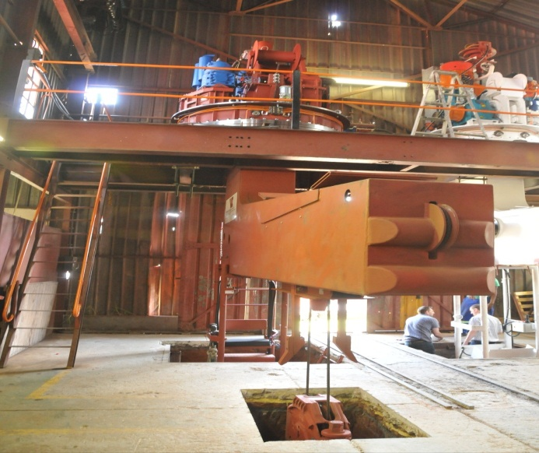
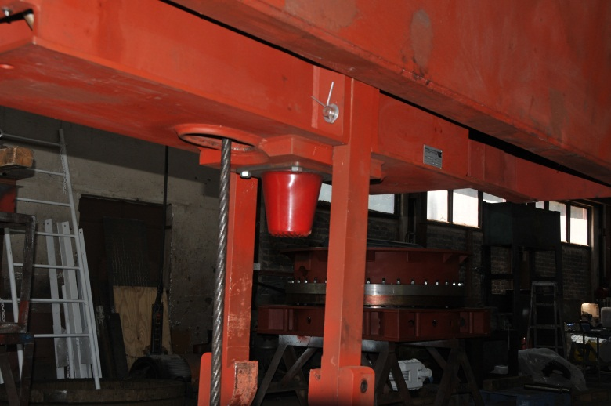 | 3.2 Crosshead Buffer
3.3 Crosshead Buffer, crosshead and extended jack catches | 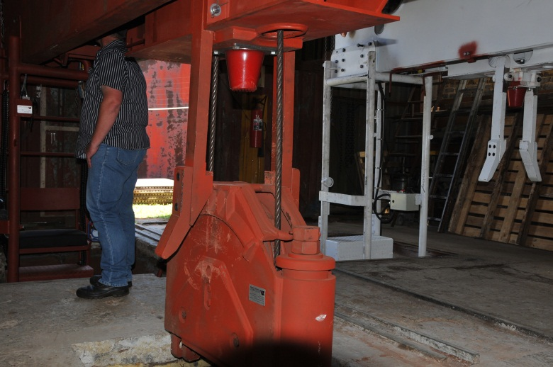
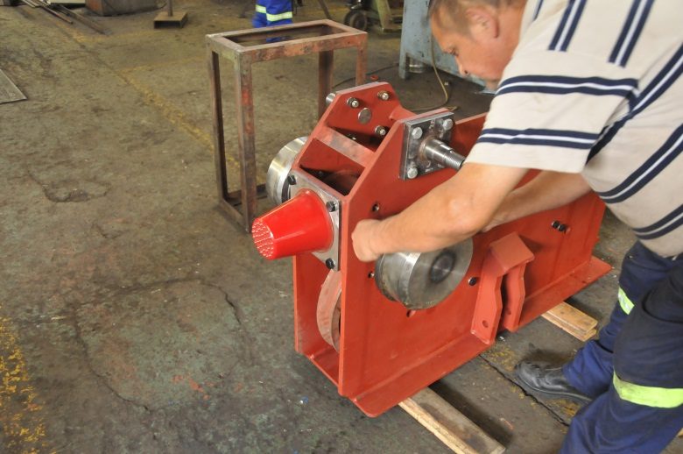 | 3.4 Traverse trolley with buffer.
3.5 Bullnose sheave. | 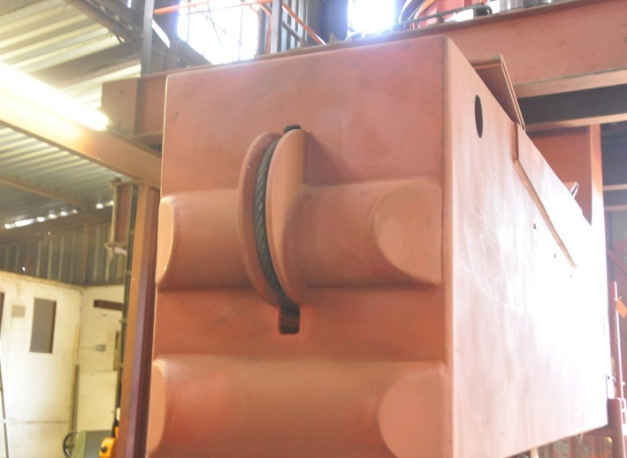
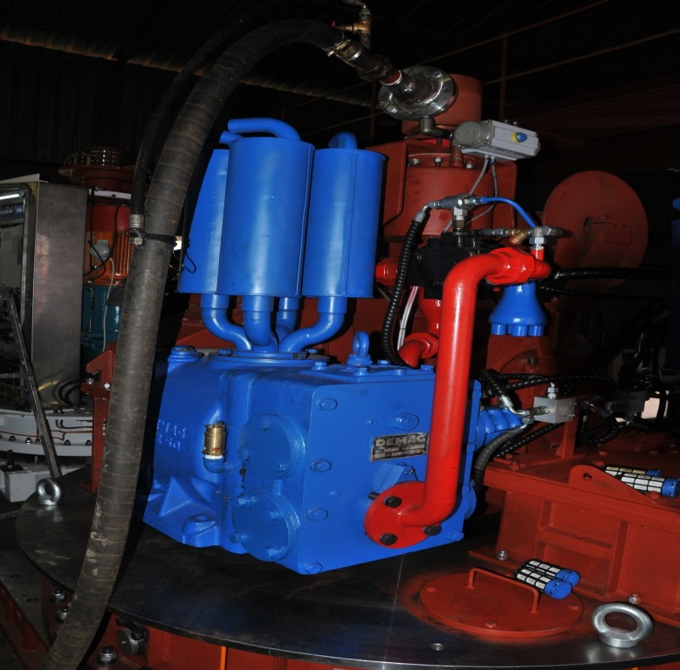 | 3.6 UZ 50 hoist motor fitted with exhaust silencers. The shut off butterfly valve is fitted with a fail to safe spring return actuator. This isolates the unit is there is a loss of compressed air or the E Stop is actuated.
3.7 Hoist brake fitted with dirt shield | 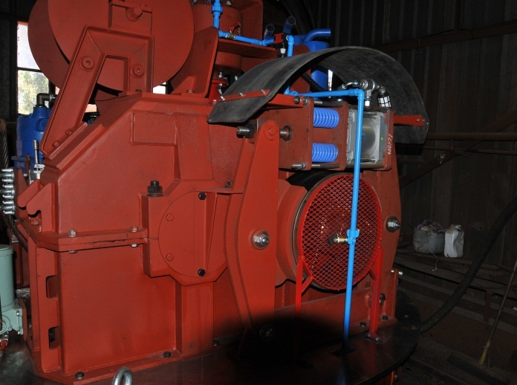
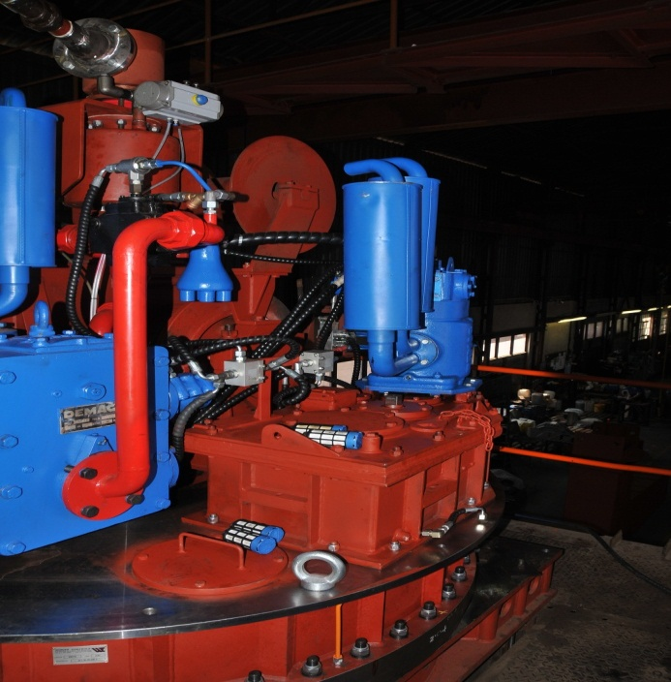 | 3.8 UZ 12 slew motor with silencers fitted. The silencers have been removed from the hoist poppet valve for demonstration.
3.9 Slew gear and slew bearing grease pump. The local hoist operating valve can be seen in this image. | 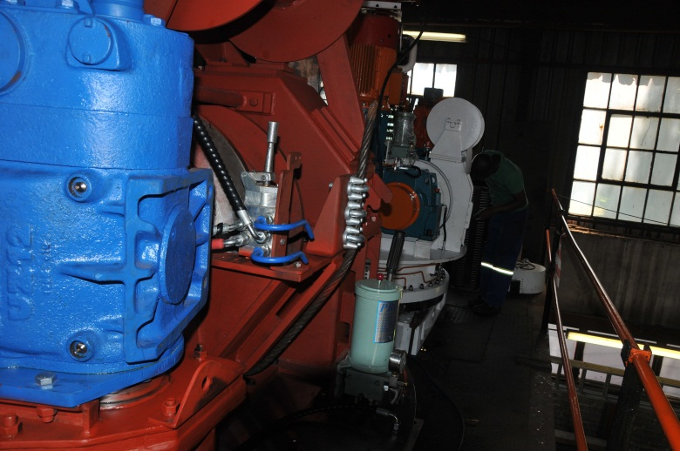
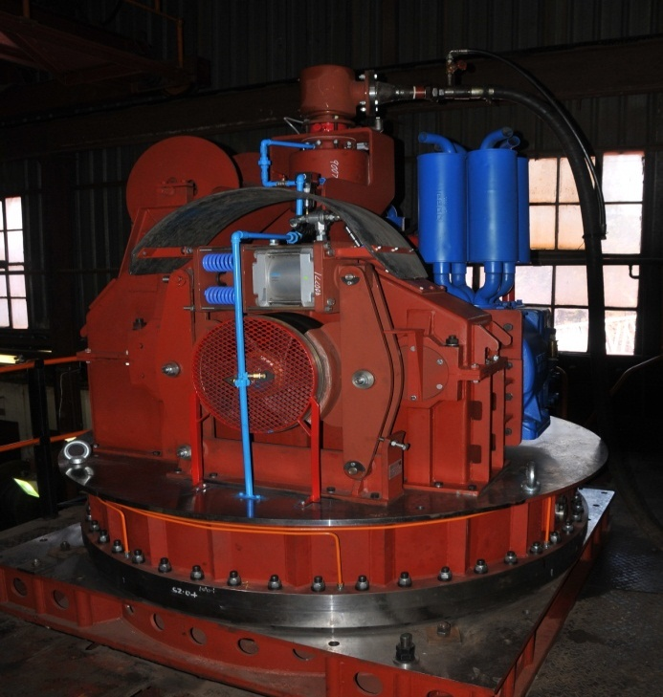 | 3.10 Lashing unit drive assembly.
3.11 Lashing unit assembly with silnecers | 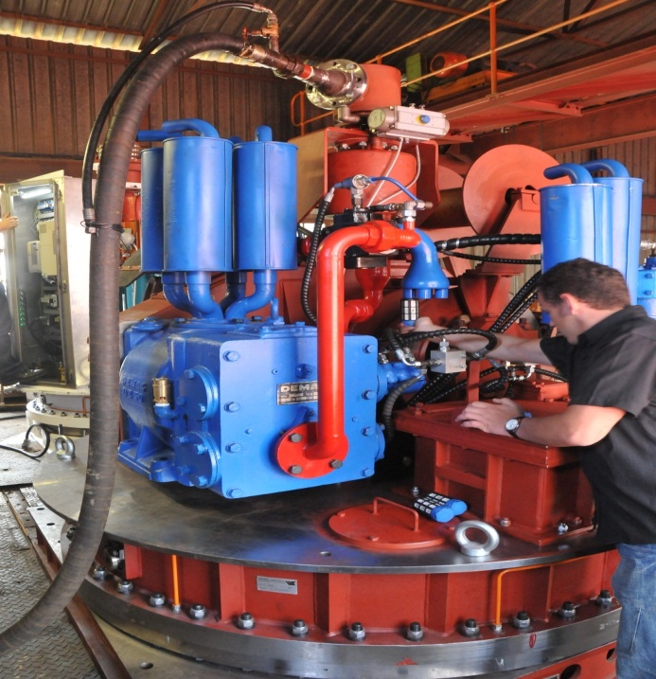
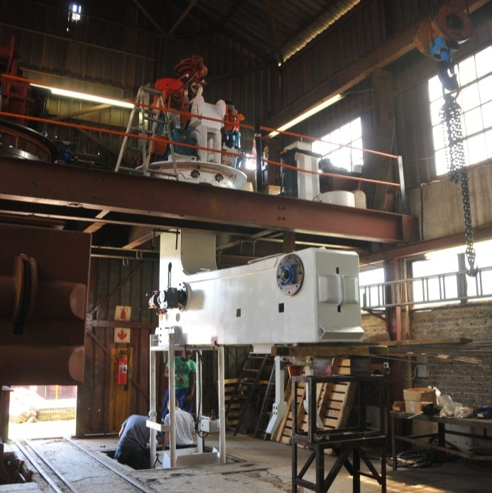 | 3.12 Electric lashing unit in the test rig.
3.13 Electric lashing unit control suite | 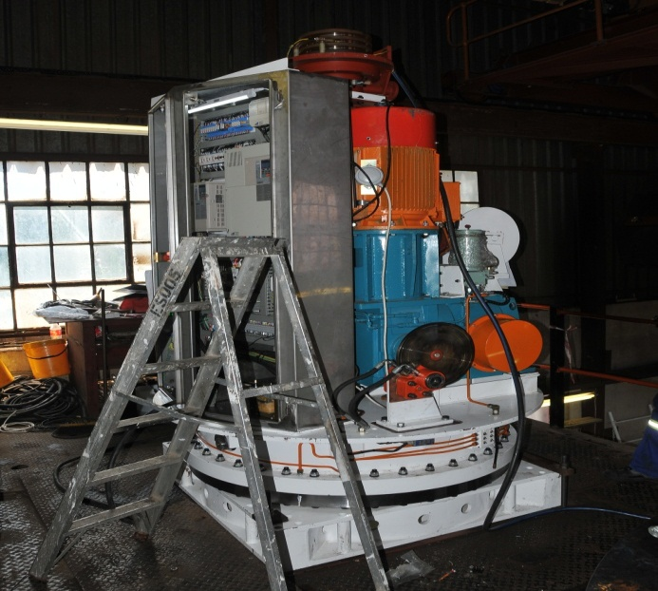
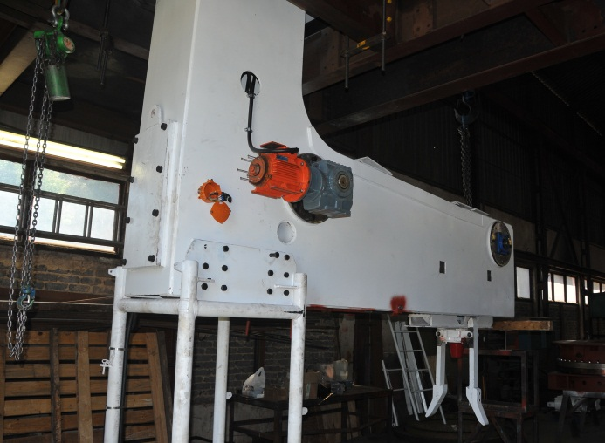 | 3.14 Electric lashing unit boom
The unit was run during the visit and substantial noise attenuation could be demonstrated.
The tests performed by Winder Controls are appended to this report.
The report is summarized below
Item | Start | Finish | Attenuation
2 inch hoist poppet valve | 117.5dB | 88.5dB | 29.0dB
Hoist brake cylinder | 104.5dB | 92.1dB | 12.4dB
UZ12 Slew motor | 102.9dB | 88.7dB | 14.2dB
UZ50 Hoist motor | 109.2dB | 80.6dB | 28.6dB
Grab operating valve | 114.8dB | 89.5dB | 25.3dB

The reader should bear in mind that the dB scale is logarithmic i.e. attenuation 10dB is a 1:10 power ratio, 20dB is a 1:100 power ratio and so on. 29.0dB attenuation is therefore a significant reduction in perceived sound levels.

Definition (Wikipedia)
The decibel (dB) is a logarithmic unit that indicates the ratio of a physical quantity (usually power or intensity) relative to a specified or implied reference level. A ratio in decibels is ten times the logarithm to base 10 of the ratio of two power quantities.

Shaft Sinkers have received a quote to retrofit a complete silencer pack to an existing unit in their fleet. It is strongly recommended that this be implemented on all existing lashing units as the reduction in noise would be a significant contribution to shaft bottom safety.

The tests performed with the electric lashing unit produced noise levels that were barely above ambient.

In addition to the silencer pack the recommendation is to retrofit the over travel buffers and the revised jack catches.

Yours faithfully

Michael Yates
Senior Project Engineering Manager
Impala 17 Shaft EPCM
TWP Projects (Pty) Limited

