ADOPTION PROCESS

1. Facilitate adoption decision
The mine must properly investigate the case for adoption the leading practice – a check-box investigation process is provided. The decision must be endorsed by the general manager and the completed form sent to the MOSH Adoption Team Manager. More

2. Secure widespread support for adoption
The support of regional and mine level union representatives must
be secured as soon as possible and a mine-wide briefing note
issued to advise of the decision to adopt the leading practice. More

3. Establish an effective adoption team
A suitable person must be tasked with leading the mine adoption
team, and another to assist in overseeing customisation of the
behavioural plans that form part of the leading practice. Training of
these persons should be discussed / arranged through the MOSH
Adoption Team Manager. The Mine Adoption Team Manager must
ensure establishment of a multi-disciplinary team with the
competencies required for successful adoption of the practice. More

4. Prepare first version adoption plan
The Mine Adoption Team Manager must arrange a team workshop
to ensure that all team members have a common understanding of
the adoption process and to prepare an initial adoption plan. An
example plan and process check-list is provided. At this stage the
team must select the piloting area for the practice, schedule
acquisition of the practice and agree the critical enablers for
successful adoption. The MOSH Adoption Team Manager can assist
with this workshop. More

5. Initiate monitoring programme
The key measurements needed to quantify performance and impacts
must be identified at an early stage collection of the necessary base-
line data must be initiated as soon as possible. More

6. Establish effective relationship with COPA
A meeting with the MOSH Adoption Team Manager should be
arranged as soon as possible after the decision to adopt to set up
appropriate COPA membership and arrangements for obtaining
support, training and other assistance through the COPA and its
members. More

7. Update key stakeholders on progress
Arrangements for keeping key stakeholders informed of progress,
challenges and key developments must be established at an early
stage to pave the way for eager adoption. This should include top
management at the mine and the COPA. More

8. Plan and conduct direct enquires
A common expert understanding of the risk situation must be
established as a datum for identifying any gaps or misunderstanding
at the mine. The generic expert risk summary must therefore be
reviewed and updated. Key persons involved in adopting the practice
must be identified and about 30 people from all levels identified for
direct enquiry interviews – Worksheet. Most importantly, suitable
persons must be selected, trained and properly briefed to conduct
the interviews. Only then should the interviews be conducted using
the questions provided. More

9. Customise generic behavioural plans
Suitable persons must be selected to analyse the interview results
using the guidance provided in an analysis worksheet. The results
must then be compared to the updated expert risk summary, the
generic mental models report, and the generic behavioural
communication and leadership behaviour plans to identify any
adjustments needed. Having made the identified adjustments the
new communication requirements should be identified. The updated
behavioural plans should then be presented to top management for
approval. More

10. Harmonise practice with mine standards
The technical elements of the leading practice must also be
reviewed and adjusted to ensure that the practice does not result in
undue disruption. Adjustments needed to harmonise the practice
with mine standards should be identified and introduced, provided
that they do not compromise the core-elements of the practice. More

11. Develop approved mine-wide adoption plan
Having customised the three legs of the leading practice to take
account of mine specific circumstances, the adoption team must
conduct a detailed risk assessment of the planned changes.
Identified risks must be addressed and mine-wide roll-out planned.
The initial adoption plan should then be reviewed, updated and
finalised for sign-off by top management. More

12. Develop training and communication materials
The customised behavioural plans and technical elements and
supplier documents must be reviewed to carefully identify and plan
the required training and both worker and supervisory levels. The
training schedules should then be established and the training
documentation and training lesson plans prepared. Arrangements
must be made to develop the required behavioural communication
material and to prepare any special documentation of signage
needed for successful adoption. More

13. Brief and train key mine persons
Prior to implementing the training programme all supervisory levels
and the workers should be briefed about the training and adoption
programme. Aspects of the behavioural communication not included
in the training programme should be implemented in these briefing
sessions and In other activities as appropriate. The required training
should then be provided as planned. More

14. Pilot adoption of the practice
Access to intellectual property and purchase of the required
equipment must be arranged as early in the adoption process as is
reasonably possible to minimise delays due to long delivery times.
The necessary maintenance infrastructure / arrangements must also
be set up in good time so that adoption of the practice is not delayed.
Adoption at the piloting site should commence on completion of the
briefing and training. More

15. Monitor, evaluate and report on performance and impacts
Procedures schedules and responsibilities for making, recording and
reporting on the necessary measurements to monitor and determine
the performance of the practice must be set up and implemented.
The performance and impact of the leading practice should be
written up and presented to management and to the COPA. More

16. Finalise and implement mine-wide roll-out plans
Once the leading practice has been successfully adopted at the
piloting site the mine adoption team need to test and document any
refinements to the practice considered necessary, and then finalise
and implement the plans for mine-wide roll-out of the leading
practice. More

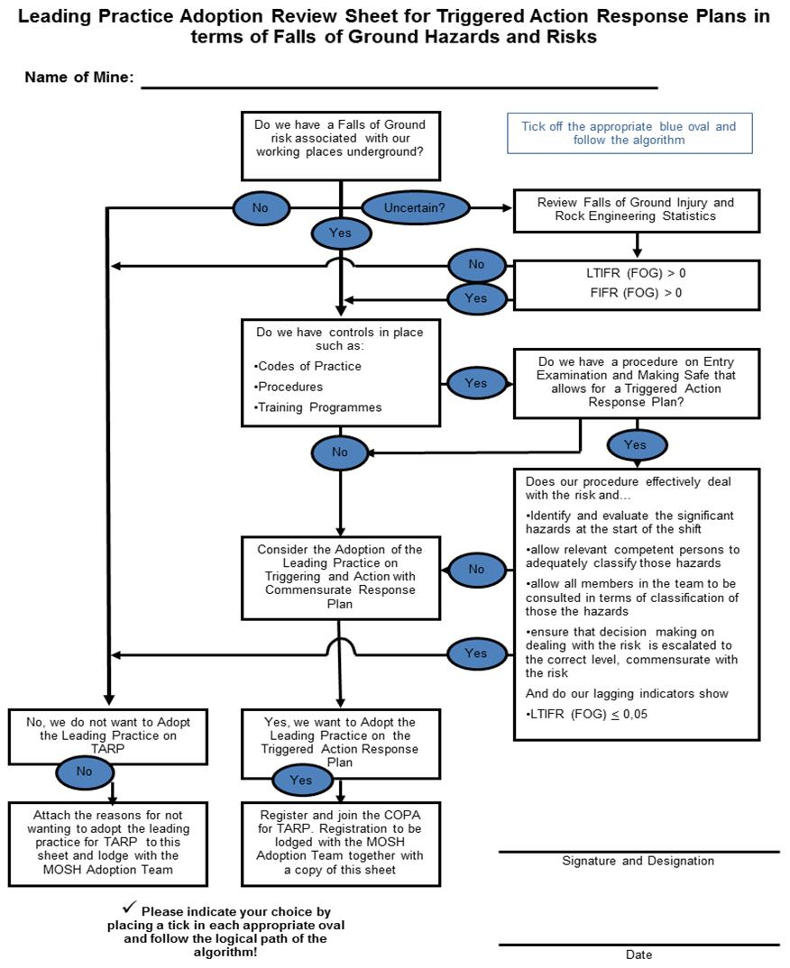
MOSH Falls of Ground Adoption Process
Community of Practice for Adoption of a Leading Practice

Registration of Interest to form part of the COPA for the Triggered Action Response Plan

A Community of Practice for Adoption (COPA) is in essence a group of people who voluntarily agree to interact with each other in a relatively informal way to share information helpful in overcoming implementation problems, and for bringing about continuous performance improvements”

The COPA will initially be managed through the MOSH FOG Adoption Team with the main objective of ensuring a successful and speedy roll-out of the leading practice for the Triggered Action Response Plan to prevent uncontrolled falls of ground.

Should you wish to form a part of this COPA, please supply your details below and we will ensure your incorporation into this COPA.

First Name
Surname
Occupation / Position
E-mail Address
Contact Number
Mining Company
Mine
Signature

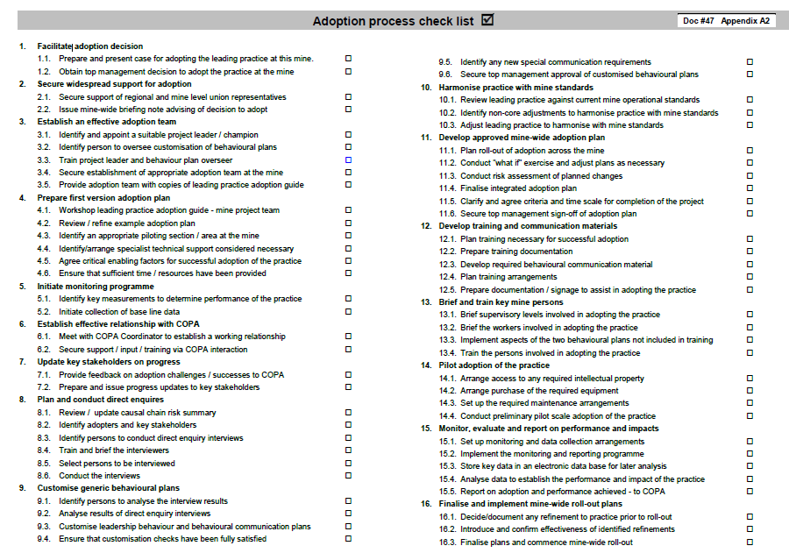
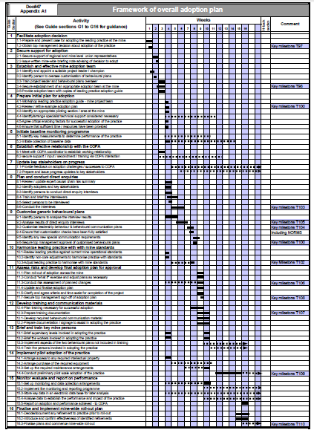
G1. Facilitate adoption decision

G1.1. Prepare and present case for adopting the leading practice at the mine:
• The relevant specialist at the mine should evaluate the case for adopting the
leading practice. (This is an implicit requirement of both the Mine Health and
Safety Act and the Mining Charter). A check box style process flow diagram for
such an assessment is provided in Appendix A3.
• The mine specific benefit and value of adopting the leading practice, or lack
thereof, should be clearly identified and documented. The generic value case
prepared by the MOSH Adoption Team should be consulted in undertaking this
assessment. It is available on MOSH website at www.mosh.co.za.

G1.2. Obtain top management decision about adoption of the practice:
• Top management at the mine need to be fully aware of what the MOSH
Leading Practice and the adoption process entail, before deciding about whether or not to adopt. To achieve a fully successful outcome they must be
supportive of both the practice and the adoption process.
• The simple explanation and diagram presented earlier, and the brochure about the adoption system presented in Appendix 4 are provided to assist in the preparation of a brief explanation of the MOSH Adoption System to top management. A 15 minute explanatory DVD is also available from the MOSH Secretariat.
• Should additional assistance be required in preparing or presenting the case to
top management, the MOSH Adoption Team Manager should be contacted.
• The Senior General Manager at the mine should record the decision about
adoption on the assessment form of Appendix A3 and arrange for the signed
form to be returned to the MOSH Adoption Team Manager.

G2. Secure support for adoption

G2.1. Secure support of regional and mine-level union representatives:
• Regional and mine-level Union Representatives should be engaged as soon
as possible to secure their understanding, buy-in and support for the leading
practice. This is crucial. The extent of the support provided, or withheld, can
greatly facilitate or inhibit the adoption process.

G2.2. Issue written mine-wide briefing note advising of decision to adopt:
• A mine-wide briefing note should be issued by management to inform
employees of the intention to adopt the leading practice at the mine. This
should be done as soon as possible after engaging the unions, and preferably
with their support.
• The note should advise that the adoption process will involve detailed
discussions with various employees at all levels to get their input into the
adoption process. (These discussions are the one-on-one direct enquiry
interviews described under G8.)

G3. Establish an effective mine adoption team

G3.1. Identify and appoint a suitable project leader / champion:
• An important aspect of top management’s decision to adopt the leading
practice must be that a suitable person will be assigned the task of leading the
project and championing the leading practice and the adoption process at the
mine. This is crucial to the success of the adoption process.
• The selected person must have time to properly fulfil the role of adoption team
manager, and leading practice champion. This is not an understatement and
the mistake of overloading a competent person must not be made.
• Systematic execution of the adoption process and successful adoption of the
leading practice should become a key performance criterion in the selected
person’s performance contract with the mine.
• The attributes of an ideal leading practice adoption team manager and
champion are provided below to assist the mine making this selection.

Attributes of a Leading Practice Adoption Team Manager / Champion ☑

1 Credibility: An essential requirement is that the champion should be credible.
This individual should preferably be someone linked directly to the specific
discipline and should be at an appropriately high level in the organisation.
He/she should have good levels of knowledge, energy, leadership,
communication skills and personal credibility.
□
2 Involvement: Having selected an individual with the right potential, it is
essential that he/she has sufficient time available to adequately perform the
functions of project management and championship. To do this, the person
needs to become deeply involved in the details of the technology as well as the
people components of the leading practice, to appreciate the issues and
problems, and to assist in, or be knowledgeable about their solution.
□
3 Leadership: An important role of the person selected will be that of providing
leadership in overcoming implementation problems that arise, including that of
energising lagging aspects of the process. It will also include the provision of
insightful input into the development of strategies and plans for the progressive
adoption of the leading practice across the mine.
□
4 Communication: A particularly key role will be that of being an effective
spokesperson for the leading practice being championed. To do this
effectively, the champion should accumulate key data and prepare appropriate
documents and presentations to communicate such performance and technical
data to interested parties, initially at the mine, but in due course on behalf of
the mine at industry workshops, conferences, and so on.
□
G3.2. Identify a person to oversee customisation of behavioural plans:
• A specific person needs to be identified and allocated the responsibility for
overseeing the process of customising the generic behavioural plans to take
account of mine specific circumstances and then integrating them into the
mine’s adoption plan. To gain the people related benefits of the MOSH
adoption process it is essential that this process is properly carried out. A
behavioural plans overseer is required to ensure that this is the case.

• The generic behavioural communication and leadership behaviour plans are
provided in Part 3, in sections P3.2 and P3.3 respectively. They are integral
parts of the MOSH Leading Practice – they address the knowledge gaps and
other identified barriers to successful adoption, and help ensure the behaviours
needed at all levels for a sustainable adoption. They must be customised to
take account of mine specific circumstances and then implemented for
adoption of the MOSH Leading Practice to be complete.

• To assist in clarifying what needs to be overseen, and why oversight
responsibility needs to be allocated to a specific person, an outline of the eight-
step process for customising the behavioural plans is presented in a single
document in Appendix A5. Relevant details are however presented at the
appropriate point in this part of the guide.

• Given that the mine may in future adopt other MOSH leading practices with
similar customisation requirements, consideration should be given to
identifying a person well placed to assist future adoption teams at the mine.
The nature of the work suggests that such a Behavioural Plans Overseer could
well be drawn from the Human Resources department.

• For other MOSH leading practices this responsibility has sometimes been
allocated to the Mine Adoption Team Manager but this has not worked well.

G3.3. Train project leader and behavioural plans overseer:
• The project leader (the Mine Adoption Team Manager) should liaise with the
MOSH Adoption Team Manager and the Group Adoption Coordinator, (if his
mining company has appointed one) to identify suitable training arrangements
for himself and the identified behavioural plans overseer.

• No formal training courses are yet available and at this stage one of the MOSH
Adoption Team Managers or one of the Learning Hub Specialists may need to
provide the necessary training and mentorship.

• An alternative that should also be explored with the MOSH Adoption Team Manager is that of arranging for the two mine persons to spend time with their equivalents at a mine that has already successfully worked through an adoption
process.

G3.4. Secure establishment of an appropriate adoption team at the mine:
• In addition to the Mine Adoption Team Manager and the Behavioural Plans
Overseer, the mine adoption team should include:
- a person from the training department,
- the line manager of the section in which the adoption process is to be
initiated,
- a person representing labour,
- a mine safety specialist, and
- a specialist in the area of the leading practice.
• All of the persons in the Mine Adoption Team must have sufficient time available to fulfil their role and responsibilities on the adoption team, and this should be appropriately reflected as a key performance area in their performance contracts with the mine.

G3.5. Provide adoption team with copies of leading practice adoption guide:
• This should be done at least a few clear days before holding a workshop to
review and initiate the adoption process. Team members should familiarise
themselves with the guide before the workshop.

G4. Prepare first version adoption plan

G4.1. Workshop leading practice adoption guide - mine project team:
• A workshop should be arranged to enable all members of the Mine Adoption
team to have a good and common understanding of both the leading practice
and the adoption process. The agenda for the workshop should include the
following:

- Opening by Mine manager to explain the steps already taken
- The case for adopting the leading practice
- Key elements of the MOSH Adoption System
- Potential assistance from the COPA and the MOSH Adoption Team
- Key technical elements of the leading practice
- The concepts of leadership behaviour and behavioural communication
- The leading practice adoption guide

• Much of the material required for the initial agenda points is in the leading
practice adoption guide, but these points should be discussed before going
through the guide to provide a context that will be helpful when working
through the guide.

• The Mine Adoption Team Manager should consider inviting the MOSH
Adoption Team Manager to attend the workshop to assist in presenting some
of the concepts and in answering some of the questions that could arise.

G4.2. Review / refine example adoption plan
• The Mine Adoption Team must properly understand and take ownership of the
adoption plan to be implemented. The framework plan provided in Appendix
A1 must thus be carefully reviewed and adjusted as appropriate to take
account of mine and team specific requirements. The adoption guide should
then also be adjusted / annotated / and used accordingly.

• The team needs to allocate date specific timing to each of the various
activities. Particular attention must be given to the time required for arranging
access to any intellectual property, capital funds or major equipment, and to
scheduling early action to minimise the impact of such time requirements.

• The team should ensure that any adjustments to the example plan do not
compromise proper customisation and implementation of the behavioural
plans. The MOSH Adoption Team Manager should be consulted in the event of
any uncertainty on this point.

G4.3. Identify an appropriate piloting section / area at the mine
• Initiation of the adoption process at the mine should be piloted in a carefully
selected site. The selected site should be:
- of sufficient size to meaningfully implement all aspects of the leading
practice that will be encountered in extending its adoption across the
mine, and
- well managed, and not beset with unusual
operational problems.
• Ensuring that these criteria are met will minimise
risks and enable adoption challenges to be
appropriately addressed.

G4.4. Identify/arrange any specialist technical support considered necessary
• During the course of reviewing and updating the framework adoption plan the
team should identify any areas where they consider specialist technical
support to be necessary.
• Training or specialist support required for handling the direct enquiry and
analysis work involved in customising the behavioural plans is dealt with under
points G8.3 and G8.4. Requirements additional to these should be arranged as
appropriate.

G4.5. Agree critical enabling factors for successful adoption of the practice
• The Mine Adoption Team and senior management at the mine should be clear
about, and agree upon, the factors which are critical enablers for adoption of
the practice at the mine to be successful.
• These factors should be identified by the Mine Adoption Team for discussion
and agreement with senior and top management.
• Consideration should be given to factors such as:
- Understanding and ownership of the adoption process
- Effective communication with all key stakeholders and operational adopters
- Adequate allocation of time and resources
- Effective customisation of the practice and behavioural plans
- Management involvement, interest and
support
- Union involvement
- Other factors identified by the Mine Adoption
Team.

G4.6. Ensure that sufficient time / resources have been provided:
• At this point the Mine Adoption Team Manager should make an explicit and
careful assessment of the time allowed for the project, and of the resources
allocated to it.

Points to consider in updating this section
• The experience gained at the first adoption (or
demonstration) mine should be reviewed and used as
appropriate when updating the guide, to provide more
specific information to assist in selecting the piloting
section at adoption mines.
Points to consider in updating this section
• Based on experience and considerations at the first
adoption mine (or demonstration) mine, when updating
the guide the MOSH Adoption Team may be able to
provide additional guidance on this point.

• The Mine Manager should be advised of the outcome of this review and at that
time any shortcomings that cannot be readily addressed by the team should be
raised with the Mine Manager.

• Both the Mine manager and the Mine Adoption Team Manager have a special
responsibility to ensure that no inappropriate short cuts or omissions occur due
to understaffing or the imposition of deadlines that are too tight.

G5. Initiate baseline monitoring programme

G5.1. Identify key measurements to determine performance of the practice
• Identification and planning of the monitoring process to acquire data to quantify
the impact of the leading practice should start as soon as possible after the
decision to adopt.
• The key measurements needed to quantitatively indicate the performance and
impact of the practice must be identified by the Mine Adoption Team well
before implementation of the practice begins.
• Consideration should be given to measuring parameters such as:
- Relevant OHS indicators
- Operational problems encountered
- Equipment availability
- Non-compliance incidents
- Relevant production indicators
- Absenteeism
• The identified parameters and the procedure and responsibility for making the
measurements should be written up in a brief document. The document should
also indicate the envisaged analysis and the responsibility for its execution.
• These details must be regarded as an important aspect of the adoption plan
and not as a nice to have.

G5.2. Initiate collection of baseline data
• Arrangements to gather the necessary baseline data must be implemented as
soon as possible, otherwise the opportunity to credibly quantify the
performance / impact of the leading practice will be lost.
• The data routinely collected by the mine simply assumed to be adequate. They
are unlikely to be fully sufficient for this purpose and additional measurements
will probably be necessary.

Points to consider in updating this section
• Based on experience and considerations at the first
adoption (or demonstration) mine, when updating the
guide the MOSH Adoption Team may be in a position
to provide more specific and helpful guidance.

G6. Establish effective relationship with the COPA more

G6.1. Meet with COPA coordinator to establish a working relationship:
• The Mine Adoption Team Manager should meet with the MOSH Adoption
Team Manager to clarify the mine’s membership of the COPA, and the nature
and extent of support and assistance that might be sourced from either the
MOSH Adoption Team, the source mine, or COPA members.

• A number of key people at the mine should already have been contacted by
the MOSH Adoption Team Manager and some may thus already be members
of the COPA. The Mine Adoption Team Manager should become the
regular member, with the Behavioural Plans Overseer attending when
necessary. It would be appropriate for someone from the mines top
management team to also be a member, but not more than this.

• A modus operandi for active and productive membership of the COPA, including obtaining assistance when needed, should be discussed and agreed with MOSH Adoption Team Manager.

G6.2. Secure support / input / secondment / training via COPA interaction:
• This must be seen as an on-going activity. Particular needs are likely to arise
as the adoption process unfolds and these should be explored through the
COPA according to the modus operandi agreed upon in point G6.1. Active
participation in the COPA will help enable this.

• Depending of the skills of identified team members, the need for support
through the COPA, in one form or another, could well emerge at an early stage
– see point G4.4. This should be acted on without delay.

G7. Update key stakeholders on progress

G7.1. Provide feedback on implementation challenges / successes to COPA
• Detailed feedback should be provided to the COPA on significant difficulties
encountered and on key successes achieved.
• Voluntarily sharing problems encountered and
successes achieved should be regarded as an
important way of learning and of passing on
hard earned experience.
• The MOSH Adoption Team Manager may wish to
arrange for the interaction and relationship with key
persons at adoption mines to be initiated differently. If
so this section should be adjusted accordingly.
• Whatever the adjustment, the net effect must be to
secure an effective working and liaison relationship
with the key persons at adoption mines, particularly
the first few mines that decide to adopt the leading
practice.

Points to consider in updating this section
• Based on experience and considerations at the first
adoption (or demonstration) mine, when updating the
guide the MOSH Adoption Team may be able to
provide more specific guidance on this point.

G7.2. Prepare and issue progress updates to key stakeholders
• The Mine Adoption Team Manager must ensure that key stakeholders are kept
informed of progress.
• Brief progress updates should be prepared and
issued regularly to the Union leaders, mine
management, and the MOSH Adoption Team
Manager.
• Progress on the adoption process should be reported to and discussed with
the Mine Manager at least once per month.

G8. Plan and conduct direct enquiries

G8.1. Review / update expert causal chain risk summary
• The Mine Adoption Team, with the assistance of relevant experts at the mine,
should critically review the causal chain expert risk model provided in Appendix
A6.
• The expert risk model should be updated to include any important mine
specific risks being addressed by the leading practice that is not reflected in the
expert model of Appendix A6.
• Discarded or added aspects should be identified and retained as they may
assist the process of customising the behavioural plans.
• In concluding the review process it is essential to ensure that all participants
have the same understanding of the risks situation at the mine that is being
addressed by the leading practice. (It is this expert understanding of the mine’s risk
situation that allows the team to identify important knowledge gaps or misperceptions that must be
addressed through the customised behavioural communication plan.)

G8.2. Identify adopters and key stakeholders
• The Mine Adoption Team must identify the adopters and stakeholders that will
be involved in the process of adopting the leading practice at the mine. This
should be done with the guidance provided by:
- the list of anticipated adopters and key stakeholders identified in Appendix
A7 , and
- The notes included on the Worksheet of Appendix A8 to facilitate
identification of the appropriate people at the mine.

G8.3. Identify persons to conduct direct enquiry interviews
• Persons trained in conducting direct enquiry interviews should be used to
conduct the interviews.
• The mining company’s Group Adoption Coordinator, if appointed, is expected
to maintain a list of persons in the Group who have been trained in direct
enquiry interview techniques, and he should be contacted to establish whether
trained persons can be made available to conduct the interviews.
• In the event that trained persons are not available through with the Group
Adoption Coordinator, the Mine Adoption Team Manager together with the
Behaviour Plans Overseer should select persons for training in direct enquiry
interview skills.
• The persons selected should not be directly involved in adopting or operating
the leading practice. They should be persons who are most likely to:
- Cause interviewees to feel comfortable within an interview setting, that is, to
feel free to speak openly and candidly about their observations and views,
- Be considered credible by those being interviewed, and
- Diligently complete each scheduled interview on time and in the required
manner.

Points to consider in updating this section
• Based on experience and considerations at the first
adoption (or demonstration) mine, when updating the
guide the MOSH Adoption Team may be able to
provide more specific guidance on this point.

G8.4. Train and brief the interviewers
• The Mine Adoption Team Manager should liaise with the MOSH Adoption
Team Manager to arrange any required training.
• The trained interviewers should be provided with the briefing material provided
in Appendix A9.
• They should then be collectively briefed by the Mine Adoption Team maanger about the leading practice, the risks being addressed, the objectives of the interview process, the procedures
and logistics of arranging the interviews, the persons they are scheduled to
interview, and the time scale of the process. They should also be taken
through the briefing material provided to them.
• The Behavioural Overseer must ensure that all interviewers know that they
must prepare for their interviews by:
- Studying and discussing the updated summary risk story with an
appropriate member of the Mine Adoption Team to ensure that they have a
thorough understanding of the risks being addressed by the leading
practice.
- Ensuring that they are fully familiar with the interviewer’s briefing and
guidance provided in Appendix A9, on conducting a one-on-one direct
interview properly.
- Practicing the interview at least once (perhaps with a mine adoption team
member), and finally,
- Reviewing with him their understanding of the interview process and how it
should be conducted and documented.

G8.5. Select persons to be interviewed
• The people selected should range across the various categories of adopters
and stakeholders in such a way as to ensure good representation of those
most involved in accomplishing adoption of the practice.
• The number of persons to be interviewed should be between 25 and 30. This
has been shown to be an appropriate number to get meaningful interview
results.
• The sample should be drawn from across the entire mine and not just the site
selected to pilot the adoption process.
• Identifiers for the selected interviewees should be entered into the worksheet
of Appendix A8. The names of those to be interviewed should not be entered
as they should be kept confidential to the Mine Adoption Team.

G8.6. Conduct the interviews
• The direct enquiry interview questions to be used in the direct enquiry
interviews are provided in Appendix A10. The interview seeks to establish the
following:
- Stakeholders/ Adopters beliefs about the causes and outcomes of the risk
- Stakeholders/ Adopters beliefs about the leading practice and how best to
protect people from the risk, and
- Stakeholders/Adopters beliefs about key leader behaviours and behavioural
communication needs
• Each interviewer should schedule all of their allotted interviews to be
conducted one-on-one in a place suitably private and free from noise and other
distractions.
• Interviewers should ask all questions fully, prompting for as complete and in-
depth answers as possible. It is the prompting aspect of the interviewing
procedure that should be focused upon in the practice sessions
• Interview responses should be carefully documented at the time of the
interview using the Interview Worksheet of Appendix A10 and the Interviewee’s
own words. It should be typed up to facilitate the analysis process.
• Recorders may be used to assist the process of accurately capturing the
interviewees responses, but only if the interviewee is explicitly asked and
clearly gives approval.

G9. Customise generic behavioural plans

G9.1. Identify persons to analyse the interview results
• Persons capable of reliably summarising the interview results must be chosen
to undertake this work. A number of the members of the Mine Adoption Team
should be well suited for this task.
• Alternatively, the task may be assigned to two or more individuals associated
with the team and adoption effort, but not to only one person.

G9.2. Analyse results of direct enquiry interviews
• Each analyst must ensure that they have a sound understanding and familiarity
with the updated expert risk model, as well as the generic mental models
report provided in Appendix A12.
• Analysts must carefully read each set of interview responses and make notes
against key questions posed in the analysis worksheet of Appendix A11.
• Working alone, each analyst should read and note their observations against
the questions posed in the analysis worksheet.
• Once all interviews have been analysed in this way, the analysts should meet
in a group session to share and compare the results of their analyses. The
analysts should identify where their individual analyses agree, and why, and
where they disagree and why. Unresolved disagreements between analysts
should be noted.
• As a group the analysts should address the main questions in the worksheet
for analysis, writing mutually agreed detailed answers to the questions, and
identifying the most influential beliefs, and their underlying rationale in the
process of doing so.
• As a final check, the analysts should re-read the interviews to ensure that they
have adequately captured and described the key beliefs expressed in the
answers to the questions asked of the stakeholders and adopters.
• Using their completed Appendix A11Analysis Worksheet, and with a view to
identifying any important differences, the results of their analyses should be
compared with the updated expert risk model and the generic mental models
report provided in Appendix A12. It is these differences that need to be taken
into account in customising the behavioural plans.

G9.3. Customise leadership behaviour and behavioural communication plans
• The Mine Adoption Team Manager and the Behavioural Plans Overseer must
ensure that they fully understand the leadership behaviour and the behavioural
communication plans and their derivation, before proceeding with the process
of customising the plan. These plans are provided in Part 3 in sections P3 and
P2 respectively.
• Customisation of the two behavioural plan must be based strictly on answers
to the guiding questions set out in the analysis worksheet of Appendix A11.
• New material to be introduced into either of the plans should be expressed in
the form of behavioural outcomes - actions that can be observed (what should
they be seen to do?) or the expression of an understanding or beliefs in
particular circumstances (what should they be heard to say?).
• In customising the behavioural communication plans the contents of each
communication should be adjusted to take account of the answers to the
questions in Appendix A11, and also the modes of communication that are
available at the mine
• The material in the generic plans should be taken as guidance on the
formulation of new content. Once updated each of the customised plans
should be checked and adjusted to ensure that it is both coherent and self-
consistent.
• The Mine Adoption Team Manager should liaise with the MOSH Adoption
Team Manager to explore the possibility of having the customised plan
reviewed, by either the MOSH Adoption Team Manager or by an appropriate
Specialist at the MOSH Learning Hub.

G9.4. Ensure that customisation checks have been fully satisfied
• The Behavioural Plans Overseer must ensure that that each of the 8 steps in
the process of customising the behavioural plans has been properly done
before allowing the team to progress to the next.
• On completion of the customisation process, a final overall check should be
done jointly by the Mine Adoption Team Manager and the Behaviour Plans
Overseer

G9.5. Identify any new special communication requirements
• The Mine Adoption Team should critically review
the customised plans in relation to the example
materials provided with this guide to identify any
new communication material considered
necessary, such as signage, posters, slides,
video etc.

G9.6. Secure top management approval of customised behavioural plans
• Given the nature of the behavioural communication and leadership behaviour
plans, and their potential impact on the management culture at the mine, the
customised behavioural plans should be presented in detail to top
management to get their buy-in and approval.
• The Mine Manager should be asked to explicitly approve implementation of the
plans
• In presenting the plans, the results of the direct enquiry process should be
highlighted – in particular the generic mental model and the new mine specific
findings should be brought out and their broad implications for the mine
discussed.

Points to consider in updating this section
• The experience gained at the first adoption (or
demonstration) mine should be reviewed at the time of
updating the guide. In particular the review should
focus on identifying more specific guidance about
sourcing or producing some of the key materials
identified in the generic behaviour communication and
leadership behaviour plans.

G10. Harmonise leading practice with mine standards

G10.1. Review leading practice against current mine operational standards
• The operational details of the leading practice must be reviewed in relation to
mine standards to identify any potential conflicts or operational problems.
• The practicality and acceptability of the operational details in implementing the
leading practice should also be tested and confirmed with the operational
managers at the mine.

G10.2. Identify non-core adjustments to harmonise practice with mine standards
• Any changes or adjustments to the leading practice that need to be made to
harmonise the practice with mine standards must be carefully assessed to
ensure that they do not detract from the essence and effectiveness of the
leading practice.
• In particular the identified changes must not impact negatively on the core
aspects of the leading practice.
• In the event that that this assessment cannot be made with certainty, the
MOSH Adoption Team Manager should be consulted.
G10.3. Adjust leading practice to harmonise with mine standards
• The Mine Adoption Team should work out when and how best to implement
and test the identified adjustments to harmonise the leading practice with mine
standards.
• If possible, this should be done before initiating the full piloting process.
• Details of successfully implemented harmonisation adjustments should be
shared with members of the COPA.

G11. Assess risks and develop final adoption plan for approval

G11.1. Plan roll-out of adoption across the mine
• The Mine Adoption Team needs to initiate planning of the process for
extending adoption of the leading practice across the mine at an early stage.
Such planning should involve:
- Obtaining input from the relevant operational managers at the mine.
- Scheduling of feedback sessions to senior management and operational
managers on progress, problems
encountered and solutions found – see G7.
- Arrangements for operational persons to visit
the piloting site at appropriate times.
- Scheduling of the envisaged roll-out
activities.

Points to consider in updating this section
• The experience gained at the first adopter (or
demonstration) mine should be reviewed and used as
appropriate when updating the guide, to provide more
specific guidance on the factors that need to be
considered and on the specific steps that should be
taken

G11.2. Conduct "what if" exercise and adjust plans as necessary
• Most mines routinely conduct a “what if” exercise in planning their project work
and a similar due diligence exercise is envisaged here, to identify and put in
place any contingency plans considered necessary.
• Each of the implementation actions should be
systematically considered by the Mine Adoption
Team in a session arranged for this purpose.
• The adoption implementation plans should be
adjusted as necessary.

G11.3. Conduct risk assessment of planned changes
• In many respects the “what if” exercise should deliver the same outcomes as a
systematic risk assessment of the planned
changes. The risk assessment must however
involve a more holistic assessment. In practice
the two exercises may be combined and be
outcomes from the same session of the Mine
Adoption Team.

G11.4. Update and finalise adoption plan
• Having completed the planning process the adoption plan should be updated
to reflect any changes considered necessary and finalised for presentation to
top management at the mine. The plan should be in a convenient format and
form for on-going review and use.

G11.5. Clarify and agree criteria and time scale for completion of the project:
• The Mine Adoption Team should critically review the finalised adoption plan
and agree the criteria and timescale for completion of the adoption process.
• It is important to specify criteria for completion of the adoption process so that
both the Mine Adoption Team and Mine Management have the same
understanding of when the adoption process is complete.
• The criteria for completion should include
successful mine-wide adoption to the point
where the leading practice is operating to the
satisfaction of the responsible operational
management.

G11.6. Secure top management sign-off of adoption plan:
• In the event that top management has been kept properly informed of progress
and developments, a formal sign-off on the implementation plan may appear to
be unnecessary at this stage. The temptation to skip this step should be
resisted.

Points to consider in updating this section
• Based on experience and considerations at the first
adoption (or demonstration) mine, when updating the
guide it may be possible to provide more definitive
guidance in regard “what if” issues that should be
considered.
• Based on experience and considerations at the first
adoption (or demonstration) mine, when updating the
guide the MOSH Adoption Team may elect to combine
points #35 and #36 into a single point concerned with
risk management
• Based on experience and considerations at the first
adoption (or demonstration) mine, it may be possible to
provide more definitive guidance in regard to the
criteria for completion when updating the guide.

• Arrangements should thus be made to present the finalised adoption plan to
top management in order to maintain their involvement and support.

G12. Plan / develop training and communication materials

G12.1. Plan training necessary for successful adoption
• The Mine Adoption Team Manager, the Behaviour Plans Overseer, the
Training Manager and the Production Manager or his nominee should together
plan the training necessary for successful adoption of the leading practice.
• The starting point of this planning process should be an in-depth consideration
of the following:
- The customised leadership behaviour and behavioural communication
plans, to identify key elements that need to be built into the training
materials for each level of the hierarchy involved in adoption of the
practice.
- The example training materials included in this guide.
- Any special training requirements identified by equipment or other service
providers associated with supply of the leading practice.
• The mine’s existing training arrangements should then also be considered in
relation to the findings from the above to clearly identify the scope and content
of the additional training considered necessary for successful adoption.
• A schedule of who is to receive what training
and when should then be developed and
agreed, initially for those involved in the pilot
adoption, but then also for others involved in
adoption of the practice as it is rolled-out
across the mine.

G12.2. Prepare training documentation
• The Mine Adoption Team Manager, the Training Manager, and the Behavioural
Plans Overseer should agree the responsibilities and procedures for preparing
the necessary training material and training lesson plans.
• The Training Manager and the Behavioural Plans Overseer should oversee the
process of developing the necessary training documents, and for ensuring a
quality outcome.

G12.3. Develop required behavioural communications material
• The Behavioural Plans Overseer and the person at the mine responsible for
developing mine communications material should meet to review and decide
upon how best to produce all of the behavioural communications materials that
arise from the behavioural communication and leadership behaviour plans.
Much of this will be for use in the training programme, but some should also be

for use elsewhere, such as in the briefing sessions and in various other
operational situations not covered in the training programme.
• The Behavioural Plans Overseer must ensure that materials produced are of
acceptable quality, and that they are produced in good time for use as
planned.

Points to consider in updating this section
• The training implemented at the first adopter (or
demonstration) mine should be reviewed to identify
any additional guidance that could be added when the
guide is updated and finalised.
• In particular, ways of avoiding or dealing any
particular difficulties that might arise in this planning
process should be provided.

G12.4. Prepare documentation / signage to assist in implementing the practice
• The Mine Adoption Team Manager and the Behaviour Plans Overseer must
together identify and arrange for production any additional documents, posters,
and signage needed to secure successful adoption of the leading practice.
• Together they must ensure that all of the communication materials for
successful implementation of the adoption process have been identified and
appropriately addressed in one way or another.

G13. Brief and train key mine persons

G13.1. Brief supervisory levels involved in adopting the practice
• The Mine Adoption Team Manager should discuss and agree arrangements for
briefing supervisors and workers involved in adoption the leading practice.
• The first of the two briefings should be held soon after identifying the key
stakeholders and adopters involved in the adoption process. The primary point
of the initial briefing should be to explain the direct enquiry process to alert
them to the fact that certain people would be selected to participate in
confidential interviews to make input into the adoption process.
• It should also be explained that in due course all people involved in adoption of
the leading practice would receive appropriate training.
• A brief description of the practice should also be given and an opportunity
provided for any uncertainties to be raised and addressed either then or in
follow-up sessions.
• The need for workers to be properly briefed about what lies ahead should also
be appropriately covered.
• The second of the two briefings should be held prior to implementation of the
training programme. The Mine Adoption Team
Manager should brief all supervisors of the
training and other arrangements relevant to
implementation of the adoption process.
• As part of this briefing, and as an aide memoir,
the supervisors should be provided with a schedule setting out details and
timing of their and their staff’s training, as well as a brief document
summarising key operational aspects of the adoption process.

Points to consider in updating this section
• Based on the experience gained at the first adoption
(or demonstration) mine, when updating the guide the
MOSH Adoption Team may be in a position to provide
more specific information and guidance of the content
of these briefings

G13.2. Brief the workers involved in adopting the practice
• The first of the two briefings supervisors must be focused on informing staff
about the direct enquiry process to obtain input into the adoption process, and
in which some staff from all levels will be invited to participate, and that all
persons involved with the practice would be appropriately trained prior to its
adoption.
• A brief description of the practice should also be given and an opportunity
provided for any uncertainties to be raised and addressed, either then or in
follow-up sessions if necessary.
• In the second of the two briefings, details about the nature and timing of the
impending training should be provided, along with
any other detail considered necessary prior to the
training sessions. The briefing may also include
delivery of certain elements of the behavioural
communications plan.

G13.3. Implement aspects of the two behavioural plans not included in training
• Much of the behavioural communication and leadership behaviour plans will
have been integrated into the training programme in one way or another (some
for delivery directly by the trainer, and some to be provided to supervisors for
their use in operational communications with those who report to them).
• Those aspects of the two behavioural plans that are not included in the training
programme should be identified by the Mine Adoption Team, along with the
persons responsible for their delivery or for ensuring that they are
implemented. This may involve persons at higher levels of management.
• The Mine Adoption Team Manager along with the Behaviour Plans Overseer
should arrange to meet with these people individually or collectively as
appropriate to properly brief them on what is required, to clarify any points of
uncertainty, and to provide them with the necessary communication material.
• Follow up sessions with various individuals should be arranged as necessary
to ensure a full understanding of what is required.

G13.4. Train the persons involved in adopting the practice
• Initiate the training process according to the training programme that has been
developed, with the initial focus being on those who require training to enable
successful adoption of the leading practice at the piloting site.
• Follow-on with the training programme according to plan, which should extend
right through to completion of the mine-wide roll-out process for the leading
practice.

Points to consider in updating this section
• When updating the guide, the MOSH Adoption Team
may be in a position to provide more specific
information and guidance of the content of these
briefings and this section should be expanded to
accommodate such guidance.

G14. Implement pilot adoption of the practice

G14.1. Arrange access to any required intellectual property
• As indicated in the example adoption plan, access to any required intellectual
property should be one of the first actions taken by the Mine Adoption Team.
This requirement should seldom arise. However, when it does, the need to
obtain such access and the process for doing so should be highlighted at the
time of presenting the case to top management for adopting the leading
practice.
• The Mine Adoption Team Manager, in liaison
with the Group Adoption Coordinator and with
the support of legal counsel when necessary,
should secure access to the required
intellectual property if the Group has not
already done so previously.

G14.2. Arrange purchase of the required equipment
• As with intellectual property, arrangements for the purchase of the equipment
may need to start at a time similar to that of arranging access to any required
intellectual property, particularly if long delivery times apply, or if the purchase
is subject to a lengthy capital approval process.
• Depending on the time scale on the procurement
process, scheduling of the various adoption
activities may need to be substantially adjusted,
and perhaps to some extent reordered.

G14.3. Set up the required maintenance arrangements
• The Mine Adoption Team Manager must arrange for any required maintenance
arrangements to be set up as an integral part of the leading practice, as
outlined in PART 3 of this guide.
• In doing so, any aspects of the behavioural
plans that are applicable to the maintenance
arrangements should also be put in place.

G14.4. Conduct preliminary pilot-scale adoption of the practice
• Most of the arrangements for implementing the practice at the pilot site should
already have been taken through the training or briefing activities outlined
above.
• The Mine Adoption Team Manager should meet
with the team of supervisors responsible for
installing the required equipment and or
procedures to arrange implementation the practice, and to deal with any other issues that need attention, including those raised by the operational supervisors.

Points to consider in updating this section
• In the event that there is a need to acquire access to
intellectual property the MOSH Adoption Team should
provide clear detail about this in PART 3 of the guide.
• This section should include reference to that detail, as
well as setting out more specific detail that would be
appropriate to add here
• The experience at the first adoption (or demonstration)
mine could point to more specific guidance that should
be included in this section when the guide is updated.
• Based on experience and considerations at the first
adopter (or demonstration) mine, the MOSH Adoption
Team may be able to provide additional guidance on
this point.
• Based on experience and considerations at the first
adoption (or demonstration) mine, when preparing or
updating the guide the MOSH Adoption Team may be
able to provide more specific guidance on this point.

G15. Monitor, evaluate and report on performance

G15.1. Set up monitoring and data collection arrangements
• The Mine Adoption Team manager should
ensure that effective arrangements are put in
place for making and recording the necessary
measurements, and for gathering any other data
needed to assess the performance and impact of the leading practice being
adopted.

G15.2. Implement the monitoring and reporting programme
• The Mine Adoption Team Manager must ensure consistent implementation of
the monitoring and reporting arrangements that have been put in place, that
that quality gathered data is being gathered, and regularly reported.

G15.3. Store key data in an electronic data base for later analysis
• The Mine Adoption Team Manager should ensure that all data is entered into
an electronic data base for later analysis. This should be seen as an integral
part of activities G15.1 and G15.2

G15.4. Analyse data to establish the performance and impact of the practice
• Once sufficient data has been collected, the Mine Adoption Team Manager
should arrange for the data to be analysed to establish the performance of the
practice and the impact that it has had at the mine.
• This should be written up in the form of a brief report for presentation to key
stakeholders, starting with top management, who should be given the chance
to comment on the report before it is finalised for wider distribution.
• The report should then be distributed to all
key stakeholders, including those directly
involved in the adoption process. Supervisors
should be tasked with sharing outcomes with
their staff at the earliest opportunity.
• At least one follow up report should be prepared within the next 6 to 12 months
to identify any longer-term impacts, and consistency of the performance
achieved.

G15.5. Report on adoption and performance achieved - to COPA
• In the example adoption plan provided in Appendix A1, a number of the
activities are identified as key milestones. The Mine Adoption Team Manager
should advise the MOSH Adoption Team Manager when each of these key
milestone activities have been completed. This will assist in keeping the COPA
and Executive Management in Industry advised of the extent to which the
leading practice has been adopted at mines.
• On completion of the brief report referred to in point G15.4, the Mine Adoption
Team Manager should arrange to make a presentation at a COPA meeting
about the mine’s experience in adopting the leading practice.

Points to consider in updating this section
• Based on experience and considerations at the first
adoption (or demonstration) mine, when updating the
guide the MOSH Adoption Team may be able to
provide more specific guidance on this point.
• Based on experience and considerations at the first
adoption (or demonstration) mine, when updating the
guide the MOSH Adoption Team may be able to
provide more specific guidance on this point.

G16. Finalise and implement mine-wide roll-out plan

G16.1. Decide/document any refinement to practice prior to roll-out
• The Mine Adoption Team Manager must monitor progress at the piloting site
closely to identify any particular difficulties encountered. Any special measures
taken to address such difficulties should be carefully documented.
• Depending on operating experience during of the piloting phase, at an
appropriate time the Mine Adoption Team Manager should convene a meeting
to review the adoption experience and consider and decide whether any
refinements to the practice are necessary.

G16.2. Introduce and confirm effectiveness of identified refinements
• In the event that some form of refinement is considered necessary, the Mine
Adoption Team should arrange for any necessary refinements to be
implemented and tested until their effectiveness has been satisfactorily
confirmed.
• The details of the refinements introduced should then be documented in detail
to ensure consistent implementation as the practice is rolled-out across the
mine. Details of the refinement should be provided to the MOSH Adoption
Team Manager for presentation at a future COPA meeting.

G16.3. Finalise plans and commence mine-wide roll-out
• As soon as the leading practice is working satisfactorily at the pilot site, the
roll-out process should be initiated.
• This should begin with a critical review of the roll-out plans developed earlier,
to identify any adjustments that may need to be made to take account of
experience to date.
• Once these adjustments have been made an effectively communicated to all
concerned, implementation of the roll-out plan should proceed.

