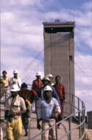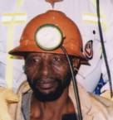ttth

AGENDA FOR NETTING WITH BOLTING COPA
20 March 2013
Randfontein Golf Club
Time: 8:30 for 9h00
- Safety Briefing - Chris Legodi
- Welcome- Chris Legodi
- Attendance and apologies Chris Legodi
- Introduction and welcoming of new members Chris Legodi
- Report back on survey Chris Legodi
- Plan for future COPA meeting Duncan Adams
- TARP Investigation Tool, Charter requirement Duncan Adams
- TARP /Alert Lonmin
- Exercise of the day Duncan Adams
- BRPM Presentation Christo Hassbroek
- Doornkop Presentation Mark Grave
- Feedback from Mines Duncan Adams
- Progress monitor feedback Chris Legodi
- COPA SURVEY Duncan Adams
- General
- Closure – setting the date and venue of the next meeting

