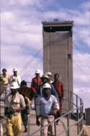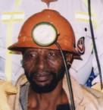

AGENDA FOR NETTING WITH BOLTING and TARP COPA
10 May 2013
Randfontein Golf Club
Time: 8:30 for 9h00
9h00
- Safety Briefing Chris Legodi
- Welcome Chris Legodi
- Attendance and apologies Chris Legodi
- Introduction and welcoming of new members Chris Legodi
- Discussion on parallel COPAs Chris Legodi
- Nets with Bolts discussion and Monitor update Chris Legodi
- Nets with Bolts Summary Duncan Adams
- BREAK
- 10h30
TARP
10h45
- Mines report back Duncan Adams
- TARP monitor and discussions Duncan Adams
- Discussion on way forward:
1. Prepare first version adoption plan
2. Initiate monitoring programme
3. Update key stakeholders on progress
4. Plan and conduct direct enquires
12. MHSC Research Report back Woute van Aarde
13. Closure – setting the date and venue of the next meeting

