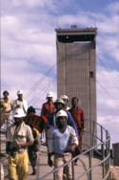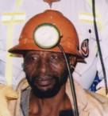

AGENDA FOR NETTING WITH BOLTING and TARP COPA
14 June 2013
Randfontein Golf Club
Time: 8:30 for 9h00
9h00
- Safety Briefing Chris Legodi
- Welcome Chris Legodi
- Attendance and apologies Chris Legodi
- Feed back on Survey Chris Legodi
- MOSH Awards and Criteria(Mine Safe) Chris Legodi
- Nets with Bolts discussion and Monitor update Chris Legodi
- Successes with Nets and Bolts Duncan Adams
10h30 Break
TARP
10h45
- Mines report back on previous work Duncan Adams
- TARP monitor and discussions Duncan Adams
- Discussion on way forward:
- Customise generic behaviour plans
- Harmonise practice with mine standards
12. Additional COPA interactions ALL+
13. Closure – setting the date and venue of the next meeting

