Index - Portfolio of Evidence for TARP Adoption
Start-up
- Algorithm
- Sign up to COPA
- Mine Adoption Team
- Program adapted for mine
Behavioural Issues
- Interview Training
- Interviews
- Mental Model Report
- Leadership Behaviour
- Behavioural Communications
Application
- Description of the LP as it will be applied at the mine
- Lesson plans
- Roll out plan
- Risk Assessment of LP Adoption
- Presentation to Mine Management and sign-off of final plan my manager
- Progress to date
Appendices
- Measurements – Base line and progress
- Mine-wide communications

Portfolio of Evidence for TARP Adoption

Start-up
- Algorithm
- Sign up to COPA
- Mine Adoption Team
- Program adapted for mine
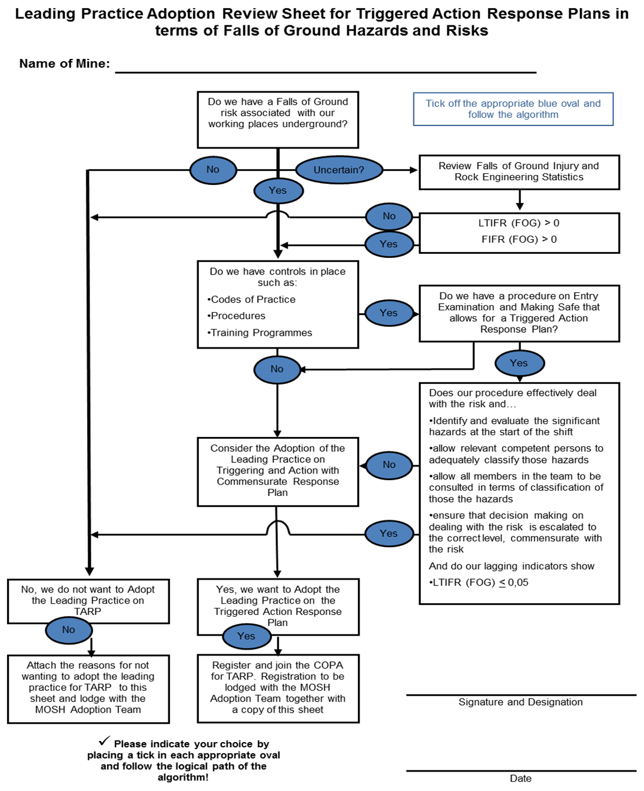
MOSH Falls of Ground Adoption Process
Community of Practice for Adoption of a Leading Practice

Registration of Interest to form part of the COPA for the Triggered Action Response Plan

A Community of Practice for Adoption (COPA) is in essence a group of people who voluntarily agree to interact with each other in a relatively informal way to share information helpful in overcoming implementation problems, and for bringing about continuous performance improvements”

The COPA will initially be managed through the MOSH FOG Adoption Team with the main objective of ensuring a successful and speedy roll-out of the leading practice for the Triggered Action Response Plan to prevent uncontrolled falls of ground.

Should you wish to form a part of this COPA, please supply your details below and we will ensure your incorporation into this COPA.

First Name
Surname
Occupation / Position
E-mail Address
Contact Number
Mining Company
Mine
Signature

Check-list
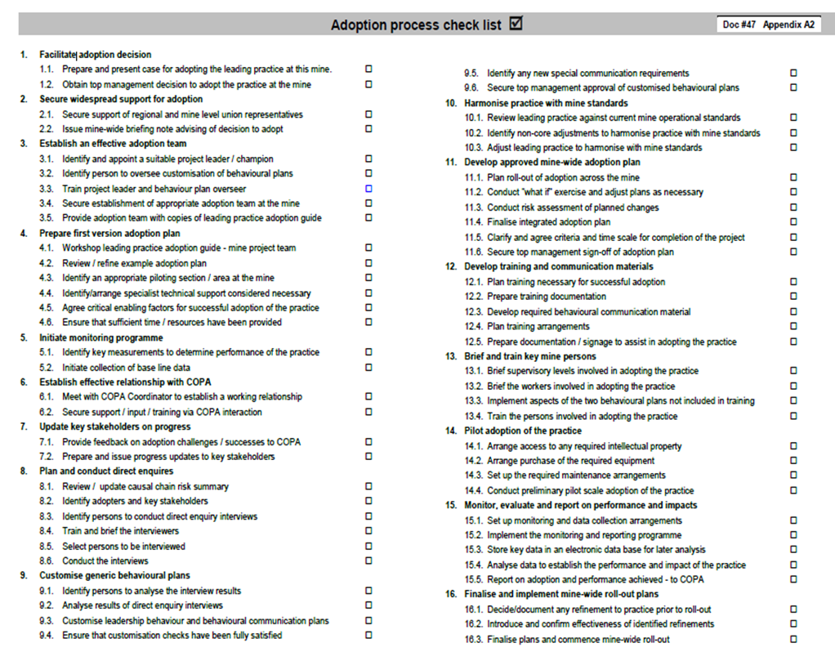

Mine Adoption Team
Name | Mine Position | Portfolio on Adoption Team
 |  | Mine Adoption Team Manager
 |  | Behavioural Plans Overseer
* Make sure you have organised labour represented
Dates of Mine Adoption Team meetings
Date | Names of members who attended

Attach any minutes of Mine Adoption Team Meetings

Behavioural Issues
- Interview Selection and Training
- Interviews
- Mental Model Report
- Leadership Behaviour
- Behavioural Communications

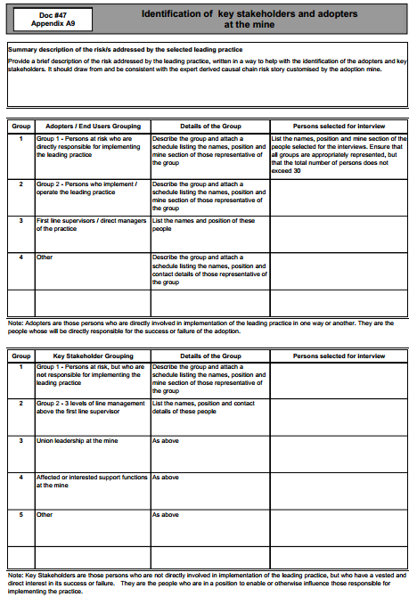

Name of Leading Practice: TARP
Instructions: Interview in mother tongue wherever possible. No line managers should be interviewers.
Name of Interviewer |  | Interview Date |  | Name of Mine | Name of Worker Position
Part A: Adopter/Stakeholder beliefs about [the hazard]
1 | Please describe your role and responsibilities at the mine.
2 | Please describe falls of ground(FoG) in your own words.  - How may FoGs occur?  - What are the possible causes of FoGs?
3 | What happens as a result of FoGs?  - How might you be affected by FoGs?  - Who else may be most affected by FoGs?  - What may happen to people who are  affected by FoGs?
4 | How important do you think it is to find a way to better protect people FoGs?  - Why do you say that?
Part B: Adopter/Stakeholder Beliefs about Leading Practices
5 | What do you think could be done to better protect people from FoGs?  Why?
Interviewer say: This mine is currently working to introduce leading practices to better protect people from FoGs. Describe the proposed leading practice of TARP in simple neutral terms.
- TARP stands for Trigger Action Response Plan
- All situations causing Falls of Ground on our mine are identified and photographed or drawn in pictures
- Each situation that occurs will be handled by a level of supervision according to its danger and ability to cause harm
- The level is assessed by an expert on the mine and given a colour green, orange or red.
- Green means the team can handle the situation.
- Orange means that the team should call for assistance from the shiftboss, the strata control officer, the full time safety rep and the safety officer.
- Red means that the team should call for the assistance of the mine overseer, the mining manager, the rock engineer and the chief safety officer.
- Decisions on the solution are recorded for orange and red situations in the rock mechanics department.
- When interviewing deciders at the mine e.g. managers, remember to talk about MOSH consisting of three legs. The practice itself, plus Leadership Behaviour and Behavioural Communications
6 | What should leaders and supervisors in the mine do to help make sure that this practice is successful?  Why should they do this?
7 | What should leaders not do in order to make sure that this practice is successful?  Why should they not do this?
8 | What other kinds of things might stand in the way of the leading practice being successful at this mine?  How should these things be addressed?
9 | What information would be important for people like you to know about how people can be affected by the risk and what is being done to protect them?  Why is this important?
10 | What is the best way for people like you to receive this information?  Why is this the best way?

Generic Mental Models Report
Major Theme | Sub theme | Description of Theme | Summary of Research Findings
Cause of FOG | Non compliance | Non compliance to standards: poor support, poor entry examination. | Interviewees were almost unanimous on this point citing negligence, short cuts, focus on targets and complacency as reasons
Barriers or Challenges to Address | Attitudes | People will come up with invalid reasons not to enter working places | This was mentioned by a Mine Overseer, but it is probably a wider concern.
Barriers or Challenges to Address | Need | People don’t perceive the need for new interventions | One interviewee felt that people may say they don’t need it because they achieved their safety and production targets already. Another said that such campaigns only happen after a problem has occurred.
Barriers or Challenges to Address | Effort | The LP may be seen as causing more work | People may resist this on the basis that they will have extra work to do for which they are not remunerated
Barriers or Challenges to Address | Production pressure | The LP may retard production | One interviewee believed that the miner may be expected to continue work despite the fact that a hazard has been escalated. A MO cited production pressure as a barrier
Barriers or Challenges to Address | Remuneration | People want to be compensated if the system involves more work | ‘The most important thing to the workers is money, they must be satisfied’  ‘There must not be changes to people’s conditions’  ‘Recognise people by uplifting their wages’
Barriers or Challenges to Address | Discipline | Punishing people for using the system | ‘People must be made aware that they are not going to be charged’  ‘Management must not threaten the people about their performance of the day’
 | Poor Leadership | Leadership behaviour that is de-motivating | ‘Belittle’  ‘Undermine’  ‘They think they don’t need to talk to you because they are on a higher level’  ‘Do not attend to my interests’  Care came up a few times. A good example: ‘When you were off sick and you return to work, they will not ask you how you are and if you are able to work. They will say look how much work have you left here’  ‘Dishonesty’  ‘Shouting at us’  ‘Have outbursts’  ‘Never listens’
Aids that will facilitate implement-tation | Participation | Involve all stakeholders in the process, most importantly, Management must listen to and respond to worker needs and views | This view was held by the vast majority of interviewees. Examples of what was said are:  ‘Involve employees and their union in the process’  ‘People must have ‘freedom of speech’  ‘People must work as a team’  ‘We must work as co-workers’  ‘People must ‘own’ the project’  The manager ‘must not do this thing on his own and afterwards tell us’  ‘He must hear our opinions  ‘Listen to the complaints of the workers’  ‘Work together with the people’  ‘Listen to what we bring to them, give full attention’  About supervisors: ‘they are workers as well’  ’They must know what the workers need’  ‘Managers must have ways to have meetings with us so that they can hear what our complaints are’  ’We must feel free to discuss issues’  ’Listen to our complaints and we will be able to work together in the right way’

Aids that will facilitate implement-tation | Values | Piggyback on the mines existing values | Interviewees at all levels made reference to “our values” Examples:  ‘motivate people using the values of the mine’  ‘Communication, commitment, respect, honesty and recognition’
Aids that will facilitate implement-tation | Accountability | People at the appropriate level will be accountable to declare a workplace safe | ‘People at the lowest level will not be unnecessarily punished; the ‘people in charge’ will bear the responsibility’
Aids that will facilitate implement-tation | Communi-cation | People must be properly informed and constantly reminded | Literally all interviewees mentioned the importance of communication:  ‘Frequent meetings’  ‘Explain it properly’  ‘Explain the benefits’  ‘Create a common understanding’  ‘Explain fully’  ‘Be understood clearly’  ‘Be demonstrated practically’  ‘Explain to people why’  ‘Keep reminding the people’  ‘Do it continuously until it is entrenched’  ‘Up and down – not telling, rather sharing and getting a common idea’  Face to face down the line by far the most preferred method of communication - in team context  Written communication not preferred.
Aids that will facilitate implement-tation | Training | People must be able to work according to the system | A substantial number of interviewees expressed the need for proper training.
Aids that will facilitate implement-tation | Management commitment | Leaders at all levels must show their commitment to the project. | Most interviewees agreed that the project must be driven from the top.  ‘They must practice what they preach’  ‘Management must be patient’  ‘The top management must not say it’s too expensive, safety comes first’  ‘Management must not preach safety but only be concerned about production’
Aids that will facilitate implement-tation | Leadership | Effective leadership to motivate the people | ‘Supervisors must be approachable’  ‘They must listen to the workers’  They must be visible’  Supervisors ‘must not speak rudely or in an unpleasant manner to the people. They must talk nicely’  ‘Management must be visible, talk to the people’  ‘Lots of interaction, talk to the people’  ‘Work together with the people’  ‘Physical visits to the working places’  Management ‘must understand what it is about before explaining it to the people’  ’The leader must know what he talks about’  ‘Honesty is important, tell them if you don’t know’  ’Clear instructions’

Leadership Behaviour Plans for Team Members, Team Leaders, Miners, Production Supervisors, Shift Bosses, Mine Overseers and Managers concerned with the Leading Practice for TARP.

Team Workers (and or “Competent persons” – Team Leaders)
Antecedents  (Required inputs or “prompts” for desired behaviour) | Desired Behaviour of Team Member
  People trained and competent in applying support standards
  People trained and competent in hazards (trigger) identification
  People empowered to activate a trigger with their team
  People have a thorough understanding of the triggers (causes, results and remedies).
  Give everybody a TARP card.
  Give them the resources they need to do the job
  Address people’s concerns:
  - Err on the side of caution but do not misuse the system not to work
  - Why it is necessary to introduce TARP
  - TARP is not additional work??? (If it is, what about compensation?)
  - TARP will initially negatively affect production, but that’s OK
  - They will not be victimized for using the system, they are empowered to do so
  Comply with support standards
  Identify triggers consistently at every entry examination.
  Unconditional following of the rules-do not enter a red or yellow panel
  Rather err on the side of caution when deciding to trigger.

Miners
Antecedents  (Required inputs or “prompts” for desired behaviour) | Desired Leadership Behaviour
  Trained and competent in hazards (trigger) identification
  Empowered to activate a trigger with their team
  Have a thorough understanding of the triggers (causes, results and remedies).
  Always have a TARP card.
  Have the resources to do his job
  Be competent in leadership and coaching
  When the team apply TARP correctly provide immediate, positive and certain feedback (thank them, recognize, reward etc)
  Strictly no blame of team if panels are stopped with the TARP process
  If false alarms - do not react negatively. Use it as a learning experience. (coaching)
  Always demonstrate a positive attitude towards TARP.
  Strictly no negative consequences if people stop operations because of TARP.
  Be respectful and caring
  Coach if the people get it wrong, again immediate, positive and certain.
  No dishonesty on the paperwork
  Identify triggers consistently at every entry examination.
  TARP to be an agenda item at all waiting place meetings.
  Open communication to lowest levels, no seniority barriers during interaction.
  The miner cannot overrule the team when they impose a trigger
  Treat people as equals when it comes to safety
  Listen to the people
  Check the conditions against the book every time (occupational blindness)
  Unconditional following of the rules (do not enter a red or yellow panel)
  Rather err on the side of caution when deciding to trigger.

Production Supervisors / Shift Bosses / Mine Overseers
Antecedents  (Required inputs or “prompts” for desired behaviour) | Desired Leadership Behaviour
  Competent in hazards (trigger) identification
  People have a thorough understanding of the triggers
  (causes, results and remedies).
  Be competent in leadership and coaching
  When the team apply TARP correctly provide immediate, positive and certain feedback (thank them, recognize, reward etc)
  Strictly no blame if panels are stopped with the TARP process
  If false alarms - do not react negatively. Use it as a learning experience. (coaching)
  Always demonstrate a positive attitude towards TARP.
  Strictly no negative consequences if people stop operations because of TARP.
  Be respectful and caring
  Coach if the people get it wrong, again immediate, positive and certain.
  Check rating at every visit
  Talk about TARP relentlessly with every workplace visit
  No dishonesty on the paperwork
  TARP to be an agenda item at all meetings.
  Leadership to be visible (VFL) Frequent UG visits to talk about TARP.
  Walk the talk - demonstrate unwavering commitment to safety in general and TARP in particular
  Open communication to lowest levels, no seniority barriers during interaction.
  Treat people as equals when it comes to safety
  Listen to the people
  Check declarations every day.
  Unconditional following of the rules (do not enter a red or yellow panel)

Management
Antecedents  (Required inputs or “prompts” for desired behaviour) | Desired Leadership Behaviour
  Be an expert on TARP
  Be competent in leadership and coaching
  When the team apply TARP correctly provide immediate, positive and certain feedback (thank them, recognize, reward etc)
  Strictly no blame if panels are stopped with the TARP process
  If false alarms - do not react negatively. Use it as a learning experience. (coaching)
  Always demonstrate a positive attitude.
  Strictly no negative consequences if people stop operations because of TARP.
  Be respectful and caring
  Coach if the people get it wrong, again immediate, positive and certain.
  Unconditional management support
  Check rating at every visit
  Talk about TARP relentlessly with every workplace visit
  The manager must drive it, at least from GM level
  TARP to be an agenda item at all meetings.
  Leadership to be visible (VFL) Frequent UG visits to talk about TARP.
  Walk the talk - demonstrate unwavering commitment to safety in general and TARP in particular
  Open communication to lowest levels, no seniority barriers during interaction.
  Treat people as equals when it comes to safety
  Listen to the people
  Spot check declarations regularly

Behavioural Communication Plan: TARP Leading Practice:
Workers, Team leaders, Miners
Issue addressed & Desired Behaviour | Messages . Communication  content | Mode | Tools / means |  | When |  | Responsibility  for delivery |  | Who to  ensure | Evaluation / control  measure
Issue addressed:  Draw attention to FOG as hazard and explain the need to introduce TARP correctly and how to apply TARP correctly. | What is TARP, How does it work, why is it adopted, how it will improve safety | Training  Team meetings  One-on-o | Lesson plans  Dialogues  Coaching
Desired behaviour:  Apply support standards correctly, consistently | What the support standards are  Why it is important to work to standards (very basic rock engineering principles) | Training  Team meetings  One-on-one | Lesson plans  Dialogues  Coaching
Identify triggers at every entry examination: consistently, correctly. | What the triggers are  What the triggers look like | Training  Team meetings  One-on-one | Computer based training  Trigger chart  Dialogues  Coaching
Follow rules unconditionally (do not enter red or yellow panel) | The importance of the rules  The consequences of not following the rules | Training  Team meetings  One-on-one | Lesson plans  Dialogues  Coaching
When in doubt, rather escalate. | When in doubt, don’t take a change | Training  Team meetings  One-on-one | Lesson plans  Dialogues  Coaching
Issue addressed:  Explain the consequences of introducing TARP, i.e. what can workers expect and how must they react | You will not be blamed or victimised if panels are stopped with the TARP process. If it happens, report it to management  You will sometimes wrongly classify panels, that's OK  Panels will sometimes stand because of TARP, that's OK  Leadership may sometimes complain, tolerate that | Training  Team meetings  One-on-one | Lesson plans  Dialogues  Coaching
Desired behaviour:  Workers must adopt and persevere with TARP | If you do not stop and fix and there is an accident, the panel will stand for longer than when you stop it  Safety is more important than anything else - Remember: “It is better to lose the production than a person”  TARP the only way to mine, there is no other way | Training  Team meetings  One-on-one | Lesson plans  Dialogues  Coaching
Issue addressed:  Workers concerns regarding TARP | The introduction of TARP will not entail extra work | Training  Team meetings  One-on-one | Lesson plans  Dialogues  Coaching
Desired behaviour:  Workers must adopt TARP | Remember: “It is better to lose the production than a person” | Training  Team meetings  One-on-one | Lesson plans  Dialogues  Coaching
Issue addressed & Desired Behaviour | Messages . Communication  content | Mode |  | Tools / means |  | When |  | Responsibility  for delivery | Who to  ensure |  | Evaluation / control  measure
Issue addressed:  Draw attention to FOG as hazard and explain the need to introduce TARP correctly and how to apply TARP correctly.  Desired behaviour:  Apply support standards correctly, consistently  Identify triggers at every entry examination: consistently, correctly.  Follow rules unconditionally (do not enter red or yellow panel)  When in doubt, rather escalate. | What is TARP, How does it work, why is it adopted, how it will approve safety  What the support standards are  Why it is important to work to standards (very basic rock engineering principles)  What the triggers are  What the triggers look like  The importance of the rules  The consequences of not following the rules  When in doubt, don’t take a change | Training  Team meetings  One-on-one  Training  Team meetings  One-on-one  Training  Team meetings  One-on-one  Training  Team meetings  One-on-one  Training  Team meetings  One-on-one |  | Lesson plans  Dialogues  Coaching  Lesson plans  Dialogues  Coaching  Computer based training  Trigger chart  Dialogues  Coaching  Lesson plans  Dialogues  Coaching  Lesson plans  Dialogues  Coaching
Issue addressed:  Explain the consequences of introducing TARP, i.e. what can workers expect and how must they react  Desired behaviour:  Workers must adopt and persevere with TARP | You will not be blamed or victimised if panels are stopped with the TARP process. If it happens, report it to management  You will sometimes wrongly classify panels, that's OK  Panels will sometimes stand because of TARP, that's OK  Leadership may sometimes complain, tolerate that  If you do not stop and fix and there is an accident, the panel will stand for longer than when you stop it  Safety is more important than anything else  TARP the only way to mine, there is no other way  Remember: “It is better to lose the production than a person” | Training  Team meetings  One-on-one |  | Lesson plans  Dialogues  Coaching
Issue addressed:  Workers concerns regarding TARP  Desired behaviour:  Workers must adopt TARP | The introduction of TARP will not entail extra work | Training  Team meetings  One-on-one |  | Lesson plans  Dialogues  Coaching
Miners, Shift Overseers, Mine Overseers
Issue addressed & Desired Behaviour | Messages . Communication  content | Mode |  | Tools / means |  | When |  | Responsibility  for delivery | Who to  ensure |  | Evaluation / control  measure
Issue addressed:  Draw attention to FOG as hazard and explain the need to introduce TARP correctly and how to apply TARP correctly.  Desired behaviour:  Apply support standards correctly, consistently  Identify triggers at every entry examination: consistently, correctly.  Follow rules unconditionally (do not enter red or yellow panel)  When in doubt, rather escalate. | What is TARP, How does it work, why is it adopted, likely consequences  What the support standards are  Why it is important to work to standards (very basic rock engineering principles)  What the triggers are  What the triggers look like  The importance of the rules  The consequences of not following the rules  When in doubt, don’t take a change | Training  Team meetings  One-on-one  Training  Team meetings  One-on-one  Training  Team meetings  One-on-one  Training  Team meetings  One-on-one |  | Lesson plans  Dialogues  Coaching  Computer based training  Trigger chart  Dialogues  Coaching  Lesson plans  Dialogues  Coaching  Lesson plans  Dialogues  Coaching
Issue addressed:  Ensuring adoption by subordinates  Desired behaviour:  Leaders must behave in a way that will facilitate adoption by positive re-  Enforcing the desired behaviour of their subordinates | Do not react negatively when workers escalate a hazard, even if they do it unnecessarily  When you observe people applying TARP correctly, react: positively, immediately, every time  When you observe people applying TARP incorrectly, coach them: positively, immediately, every time  MO and Shiftbosses are key drivers of the process: Talk about TARP every time you meet the crew.  You will find doing TARP very difficult in the beginning  Always show unconditional support for TARP  Communicate with the people through dialogue – it involves listening  Show respect and care | Training  Team meetings  One-on-one |  | Lesson plans  Dialogues  Coaching
Issue addressed:  Meeting the expectations of the workers in relation to the behaviour of the leadership  Desired behaviour:  React and communicate appropriately | Strictly no blame if panels are stopped with the TARP process  Panels will be wrongly classified red, that's OK  Panels will stand because of TARP, that's OK  Your actions must demonstrate that safety is more important than anything else  Demonstrate your belief that TARP the only way to mine, there is no other way  TARP requires a drastic culture change – production orientation to safety above else  Advocate the point that it is better to lose the production than a person  If you are going to drive production above safety, TARP will fail | Training  Team meetings  One-on-one |  | Lesson plans  Dialogues  Coaching

Managers
Issue addressed & Desired Behaviour | Messages . Communication  Content | Mode | Tools / means | When | Responsibility  for delivery | Who to  ensure | Evaluation / control  measure
Issue addressed:  Managers must ensure the adoption of TARP  Desired behaviour:  Create a conducive climate for adoption by behaving (doing and saying) appropriately. | Do not react negatively when workers escalate a hazard, even if they do it unnecessarily  When you observe people applying TARP correctly, react: positively, immediately, every time  When you observe people applying TARP incorrectly, coach them: positively, immediately, every time  Talk about TARP in every meeting and during every visit to workplaces.  You will find doing TARP very difficult in the beginning  Always show unconditional support for TARP  Communicate with the people through dialogue – it involves listening  Show respect and care  Strictly no blame if panels are stopped with the TARP process  Panels will be wrongly classified red, that's OK  Mine overseers and shift overseers will complain about impact on production, they need to be re-assured  Constantly communicate the notion that safety is more important than anything else  Make it clear that TARP is the only way to mine, there is no other way  TARP requires a drastic culture change – production orientation to safety above all else  Sell the notion that TARP is the best weapon to give a miner in the fight against FOG  Success is due to drive behind it from the very top  If you are going to be seen to drive production over safety, TARP will fail | Training  Team meetings  One-on-one | Lesson plans  Dialogues  Coaching  Showing / Leading by example

Application
- Description of the LP as it will be applied at the mine
- Lesson plans
- Roll out plan
- Risk Assessment of LP Adoption
- Presentation to Mine Management and sign-off of final plan my manager
- Progress to date

Example Document for recording sign-off of Mine Adoption plan by Mine Manager

Review of Mine Adoption Plan, Risk Review and Roll-out
Date
Venue
Attendance | Name | Designation
Following discussions with the Mine Adoption Team I am satisfied with the adoption process to date and proposed for the future, the harmonisation with mine standards, the risk review conducted with the changes introduced by the Leading Practice and the roll-out plan.
Name of Mine Manager
Signature
Date

Appendices
- Measurements
- Mine-wide communications

Working Place Name: | Team Leader: | Mine Overseer:
Date: | Miner: | Date of Adoption of TARP:
Number of crew members: | Shiftboss: | Other:
Measure | Without Leading Practice | With Leading Practice
Number of Yellow stoppages | n/a
Number of Red stoppages | n/a
Number of incorrect stoppages | n/a
Average Maximum and Minimum Support distance to face (m)
Average Dip and strike Support Spacing (m)
Rock related LTIs
Rock related Serious and Fatal Injuries
White Flag Days
Time taken to conduct TARP procedure | n/a
Condition of stopes/tunnels hangingwall
General Housekeeping (good/moderate/Bad)
Section 54/55s
Absenteeism in crews (Total days per week for crew)
Evidence of team work (good/moderate/bad)
Mental model changes(y/n, if y what?) | n/a
Tons per person per month
Area mines (m²) per crew
Personal Observations/ Experience/ Feedback/ Input | n/a

