

Telephone: (011) 498-7750
Telefax: (011) 834-1884
Web: http://www. chamberofmines.org.za
5 Hollard Street
Johannesburg 2001
PO Box 61809
Marshalltown 2107

7 April 2014

MOSH TASKFORCE CIRCULAR NO: 10/14
Template for Leading Practice Measurable Goals for CEO Elimination of Fatalities Task Team
MOSH Task Force: For consideration)

Background: At its meeting of 21 February 2014, the CEO Elimination of Fatalities Team approved to continue quarterly monitoring of Falls of Ground indicators and PDS adoption; and to expand the quarterly reporting to include measurable health indicators. To this end, the Health Policy Committee was tasked to make recommendations on indicators and targets that should be monitored.
The MOSH Learning Hub understands the above decision to be inclusive of the adoption of health related leading practices (both in Noise and Dust). At the MOSH Task Force meeting of 21 February 2014 the matter was discussed and the following transpired.
- In considering the proposal from the MOSH Learning Hub, members were not keen to have Leading Practice adoption goals imposed on them or decided by the Learning Hub.
- However, members
- confirmed that their companies are committed to the adoption of Leading Practices (where applicable) as part of the Culture Transformation Framework and the reporting of progress as part of the Mining Charter.
- accepted that each company/mine should have a rollout plan for adoption of leading Practices from start to finish and that it will in some cases take more than 1 year for a leading practice to be rolled out.
- agreed that the measurable goals for the CEO Elimination of Fatalities relating to Leading Practices should be the same as those which are committed in the company’s/mine’s adoption plans
- accepted that the establishment of adoption plans require co-ordination of in-house structures and role players such as GEE’s, CM&EEs, Heads of Engineering and most importantly Mine Managers and General Managers.
- agreed to facilitate such co-ordination in view of their roles as Group Champoins.
- agreed that the monitoring mechanism used by CEO Elimination of Fatalities Team for PDS adoption could be considered as a basis for all Leading Practices.

Purpose: The purpose of the circular is to propose to the MOSH Task Force a process for establishing measurable goals for Leading Practices for the CEO elimination of Fatalities Task Team and formats to be used in the process.

Proposed processes: Two processes are proposed, the first for establishing annual goals and the second for reporting progress against the goals.

Process for establishing annual MOSH Leading Practice measurable goals for the CEO elimination of Fatalities Task Team

The following process is proposed.
- Based on the company’s/mines planning and budget cycle, Leading Practice adoption is considered, planned and included for the budget period ( weeks, months or years) as per the company/mines normal process. (Only relevant if the leading practice requires a budget) The Leading Practice adoption plans are then included in the annual safety projects (or other internal) strategy and plan.
- It is envisaged that the safety plan shall include the following basic information to enable an industry view of planned Leading Practice adoption.
  - Leading Practice name, mine, start and finish dates and in wich quarters of a particular year the practice will be rolled out. For example:

If there is a group start and finish date, that will be useful, but it can also be derived from above information.
- Such plans will be made available by MOSH Task Force Members to the Learning Hub and consolidated by the respective MOSH Adoption Team for consideration by the CEO Elimination of Fatalities Team at their first meeting every year. (If they agree to make any changes it will be associated with the budget and other resource requirements)

Once the CEO Elimination of Fatalities Team agreed, the companies report their progress. (see Fig 1).

Process for reporting progress on MOSH Leading Practice measurable goals for the CEO elimination of Fatalities Task Team

Progress will be reported at COPAs as per the normal MOSH process, however since not all companies are members of COPAs CEOs are requested by the COM Safety Department to send the spreadsheet in Fig 1 to their Safety person for completion and return to the CoM. This is to ensure that CEOs have visibility of their respective company’s information before it is consolidated.

To determine the company’s progress will require more detail since actual progress are measured on a per unit / per level/mine or other practical basis. This is determined as per the specific leading Practice.

The process proposed will ensure that companies and the CEO Elimination of Fatalities Team are 100% aligned and that the only measure is progress against the agreed company plans.

Fig 1 is an example of the proposed spreadsheet adoption monitoring for the Multi Stage Filtration System Simple Leading Practice as an example:
Fig 1

The CEO Elimination of Fatalities Team will have 2 reports per Leading Practice.

The 1st is the consolidated Leading Practice planning report as prepared by the relevant adoption team.

The second being the consolidated progress plan.

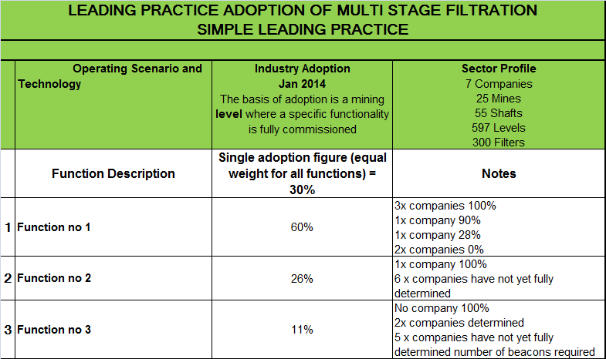

RECOMMENDATIONS

It is recommended that members approve the circular.

KOBUS BLOMERUS
ADOPTION TEAM SPECIALIST – T&M

