Comments on Noise Team Lessons Learnt

Given below are comments on the presentation about lessons learnt by the Noise Team in facilitating adoption of the HPD TAS Leading Practice. The comments should be read in conjunction with the attached set of slides, which have been annotated with numbers in bracketse.g. [#1] which correspond to the various comments presented below. Finally, it should be noted that some comments have been inserted directly into the last two slides, which have been included in this document.
- Widespread adoption phase only: It is important to realise that the foundation for the widespread adoption phase is prepared, and indeed initiated during the documentation phase, before the leading practice adoption workshop and the formation of the COPAs. The identification and communication with key persons at mines is supposed to start soon after identification of the leading practice. By the time of the adoption workshop the key deciders should thus already be well briefed about the value case and any other generic issues crucial to their decision making process. The absence or inadequate execution of this early work can thus impact substantially on what is experienced in the “widespread adoption phase”. Unfortunately, to date this has been a consistent weakness in implementing the adoption system.
- Deciding to adopt:One to eighteen months seems about right – some mines (managers) would be “early adopters” others would be “laggards”. Execution of a properly developed BC plan for Deciders before the leading practice adoption workshop should help reduce the number of laggards, but in practice one must expect a spread. Indeed, the MOSH Adoption Team would be overwhelmed if all potential adoption mines decided to adopt within the first month.
- Setting up a multidisciplinary team: Unless the manager is committed and clear about what is required, setting up the required multidisciplinary team can take time. The lesson learned here points to the need to include appropriate communication in the BC plan for Deciders about the importance of the team and the need to act swiftly to establish the required team at the mine.
- Identify interviewers & interviewees:It is inevitable that there will be a spread in the time taken to identify these. The lesson here points to the importance of the mine appointing an adoption team manager of sufficient stature and quality. The need to ensure such an appointmentshould thus be brought out in the early communication withDeciders. It should also be brought out strongly at the leading practice adoption workshop and at the first COPA. This is already covered in the updated version of the Handbook (section 6.3 and the example LPAG), but there is scope to further emphasise the points made.
In regard to identifying the interviewers, it must also be remembered the Task Force Member is now expected to play the role of a Group Adoption Coordinators, and in that role to ensure that a core group of adequately trained interviewers are available within the Group’s mines. This is now part of their terms of reference,although the practical viability of this new role still needs to be properly tested.
- Train the interviewers:At the Strategic Communications workshop on 31 May it was agreed that training for the Mine Adoption Team Manager, the Behaviour Plans Overseer and the Interviewers could be provided by the MOSH Behavioural Specialist. The lesson here is thus the need to action both this point as well as the point about the role of the Task Force member made under point 4 above. It would be unwise to increase the time allocated in the pro forma plan of the LPAG
- Mental model interviews: Unless these are well planned the interviews can easily stretch over two months. The lesson here is to ensure the appointment of a quality Mine Adoption Team Manager and the availability of trained interviewers, and not to increase the time allocation for this activity.
- LB and BC plans: It is expected that the analysis of interviews and the preparation of detailed customised BC and LB plans, including appropriate communication materials, will require at least a month. The reason for the shorter period reflected for the HPD TAS Leading Practice is likely to be an exception.
- No standardised way of assessing competency of interviewers: Yes, this is a point that is worth pursuing.Douw should be asked to comment on the practicality of doing this and to suggest how it might best be done.
- MOSH not present during the interviews: This is as it should be. This emphasises the importance of ensuring the competence of the interviewers, as covered in earlier points.
- Simple application of 5 Whys: The ability and skill in asking probing questions is linked to the issue of interviewer training and competency, as dealt with in a number of the points above.
- Some questions were not answered: Points again to the competency of the interviewer, but in some cases, if the interviewee really does not have anything to say even after rephrasing the question or appropriate probing, then so be it. It would then not be an issue.
- No vertical split of interviewees:This is an important problem. Upper levels must be covered by and involved in the determination and execution of BC and LB plans. They also need to be recipients of the plans. This brings out the importance of the adoption decision being made at mine manager level and for the appointment by the manager of a Mine Adoption Team Manager of adequate standing and quality. It is covered in the handbook example LPAG, but there is scope to bring this out more clearly.It is also something that should be emphasised by the MOSH Adoption Team during COPA meetings.
- Copy and paste responses and same answers from different people: This again points to the need for the appointment and training of quality persons as Mine Adoption Team Manager and Behaviour Plans Overseer and the use of trained interviewers. Indirectly, it also points to some of the content that should be included in the BC plan for Deciders, and to the need to bring out the importance of these appointments at the leading Practice Adoption Workshop, as well as the first COPA when senior mine persons are expected to be present. The point is already made quite strongly in the LPAG but it is worth investigating how the point could be more effectively brought out.
- Supplied generic LB & BC: It is not clear what this means since all potential adoption mines are supposed to be supplied with generic LB and BC plans for customisation purposes, using a direct enquiry process based on the relatively simple 10 point questionnaire. If the full direct enquiry protocol was used at adoption mines, then this can be expected to lead to difficulties in analysis and interpretation of the responses.
- No coding was done:Coding is not expected to be done in the customisation process at adoption mines, but it is worth pointing out that the software developed by Decision Partners “automatically” handles the coding issue.(A trail of the software was offered, but was not taken up.) Also see point 14 above.
- Same knowledge aspects listed:This might not be a problem, provided that the interviews were conducted properly. Given the earlier comments about interviewers, this observation simply adds to the importance of a competent interview process.
- Everybody wanted to be heard: This suggests that the initial briefing of the workforce was inadequate. The example LPAG indicates that workers are to be briefed at the same time as the adopters and key stakeholders are identified – see points 8.2 and 13.2 of LPAG. The briefing of workers and supervisors is intended to advise all about the direct enquiry process and to provide them the opportunity for questions and input during the briefing sessions.
- To interview 12000 people: To suggest that this should be done indicates a lack of appreciation of the qualitative research principles underlying MOSH mental models process. Generally, about 30 interviews have been found to be adequate for identifying the key aspects of the mental model of a large group of people. In some special cases it might be necessary to sub-divide the group, and to use more interviews, but this needs to be handled on an ad hoc basis. However, all 12000 people are expected to be briefed and to be given the opportunity to ask questions and to make their input, as described in point 17 above.
- Labour structure not involved: Union leadership should be involved as a key stakeholder in most leading practices. This is spelt out in point 8.2 and appendix 8 of the example LPAG. It should thus also be in the adoption teams LPAG provided to mines to guide the adoption process at their mines.
- Interviewers could not translate responses into messages and modes: In point 9.1 of the example LPAGguidance is provided about the selection of persons to analyse the interview responses. The interviewers are not expected to have the ability / skill to translate the responses into messages and modes. Instead, the example LPAG advises that some of the mine adoption team members,particularly the Adoption Team Manager and the Behaviour Plans Overseer, should be able to undertake the task of analysing the responses as a basis for customising / updating material provided in the LPAG.
- Little value for major effort: The value derived from the behavioural processes will depend on how well the process is implemented, and not on how much effort goes into it. The issue is thus really that of quality. However, notwithstanding the importance of quality, even a substandard mental models process has engagement elements that are likely to deliver quite substantial benefits, provided the generic BC and LB plans produced by the MOSH Adoption Teams are of reasonable quality, and are provided to the mine in an LPAG of good quality.
- Is direct enquiries the best way to ensure buy in:In reflecting on this question, which will always remain a valid question, it is important to recognise that there are two direct enquiry process, the one undertaken by the MOSH team across potential adoption mines to develop the generic BC and LB plans, and the other undertaken by the mine adoption team at the adoption mine to customise the generic behavioural plans. Behaviour science and years of experience by many persons have evolved the direct enquiry / mental models approach as the best way of achieving the behaviour change associated with buy in. Others are increasingly coming to this realisation.
- Specialised communication service providers: The use of external service providers to implement the behavioural aspects of the MOSH process has previously been thought of as an option, but rejected for various reasons. A fundamental aspect of the system is Industry ownership and outsourcing something so fundamentally an integral part of management / worker relationships is not considered wise in the long-term. A large part of the benefit is expected to come from management and workers properly engaging in the process
- Widespread adoption should take 4 weeks: If this conclusion is really suggesting that widespread adoption of a leading practice should be achievable within 4 weeks, then a simple comment is not possible.
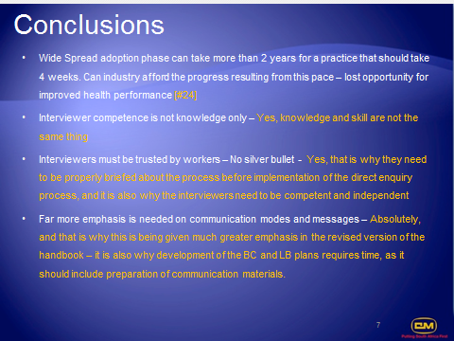
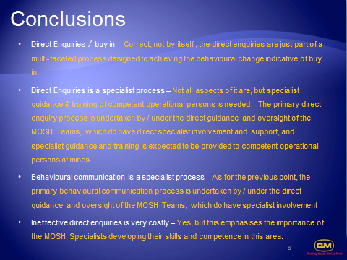

J M Stewart
5 Nov 2013

