Report on the Hearing Coach© verification investigation
Date of information gathering visit: 4th June 2013
Venue: Glencore Xstrata Mototolo Platinum Lydenburg
Introduction
Dr. Anita Edwards and Jose de Beer were tasked to investigate a possible leading practice after a hearing Coach write-up was received from Mr. Adriaan Knoesen. (Sustainable Development Manager – Glencore Xstrata Mototolo Platinum Eastern Mines).

Proposed leading practice
The investigation was aimed at evaluating the benefit of the Hearing Coach© programme to a Hearing Conservation Programme (HCP) and therefore the suitability of recommending the use of Hearing Coach© for widespread adoption to the mining industry.
Hearing Coach© uses a 4-Leaf Clover approach that is aimed at action in four different areas namely, noise levels, Hearing Protection Devices (HPDs), hearing and behavior change.
- Noise: personal noise levels of the employees are measured by the mine Occupational Hygiene department and should be integrated into the Hearing Coach programme in order to facilitate correct choice of attenuation levels of HPDs.
- Hearing protection: Custom-Moulded HPDs with the correct attenuation for the noise exposures of the employee is fitted and training on care and correct fitting must be provided.
- Hearing: Otoacoustic Emissions (OAEs) and a licensed algorithm are used to measure the integrity of the outer hair cells (OHC) in the cochlear. The results are displayed in a graph format and represented in percentage of OHC damage. This is an easy way to explain the results to an employee and to provide information regarding their hearing loss and the impact that excessive noise exposure has on their hearing. In order to optimize the reliability of the OAE measurements, the following tests must be conducted: otoscopic exam, tympanometry (middle ear analyzer) as part of the test protocol. Since OAEs can indicate cochlea function reduction before the hearing loss is identified on an audiogram the method is an early indicator of hearing loss and therefore a leading indicator of the success of the HCP.
- Behaviour: The results are explained to the employee with emphasis on the importance of compliance with wearing their HPDs and the risks that noise hold for their future quality of life as well as job opportunities.

2,200 employees including contractors.

________________________________________________________________________
Attachment 1.

Retrofit Noise Control Practice on Offer from Industry
Name of Practice:

Hearing Coach

Description of the Practice

Hearing coach uses the 4 Leaf Clover Method where action is on four different areas: Sound, Hearing protection, Hearing and Behaviour.
- Noise: personal noise levels of the employees is measured and quantified
- Hearing protection: The correct attenuation for the HPD’s is determined
- Hearing: OAE-measurement (Oto Acoustic Emissions) is one technique for early detection of Noise Induced Hearing Loss. Oto Acoustic Emissions are used to conduct a screening measurement, to measure the integrity of the outer hair cells and the inner hair cell in the cochlear. The results are displayed in a graph format and represented in percentages reflected in the OHC-Scan. This is a simple way to interpret the results to the employees and to share information regarding their hearing loss and the possible impact that excessive noise exposure has on their hearing. In order to optimize the reliability of the OAE measurements, the following tests must be conducted: otoscopic exam, tympanometry (middle ear analyzer).
- Behaviour: The results are explained to the employee with emphasis on the importance of compliances.

Benefits:
Early detection of NIHL
Individual assessment and coaching.

Constraints:
The time it takes to put everybody through the programme
Finding a suitable place to do OAE.

Costs:
R300 per person per year.

Test Results:

See the presentation

Photograph:
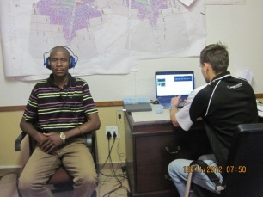
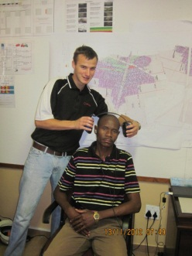
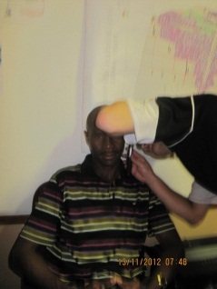

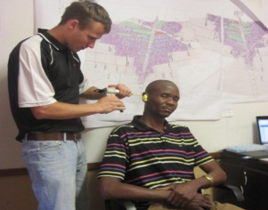
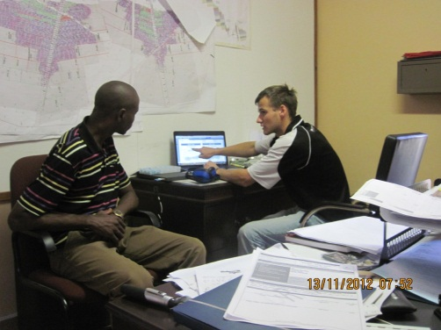

Contacts:
Name | Telephone Number | e-mail address
Adriaan Knoesen | 0132306754 | aknoesen@xstrata.co.za
Rodney Mondela | 0132306897 | rmondela@xstrata.co.za

Investigation notes as on 04 June 2013: By Jose de Beer

1.0 Introduction
A familiarization session was conducted at Glencore Xstrata Mototolo Platinum at the Eastern Platinum Mine on 04 June 2013. The aim was to obtain information and gather data on the current “Hearing Coach” OAE’s methodology used for the early detection regarding NIHL for verification purposes.

Once the investigation is completed, all data will be assessed and be verified against the Mosh process to determine if this process can be put forward to industry as a possible leading practice and use Glencore Xstrata Mototolo Platinum as a source mine.

2.0 Objective
- The objective was to have a physical demonstration of the OAE process as offered by the service provider at Mototolo Platinum.
- Secondly, to have discussions with the key role players and to visit the Occupational Health Centre on how the process is managed from employee baseline studies towards managing affected employees and contractors throughout the company.

Attachment 3. (Demo what the OAE process consists off)

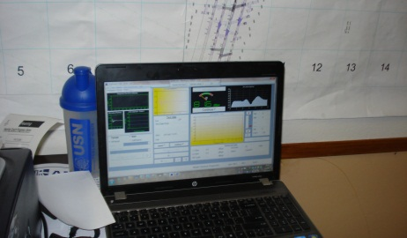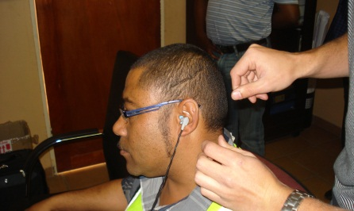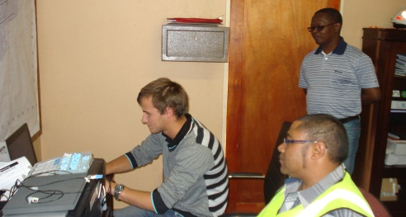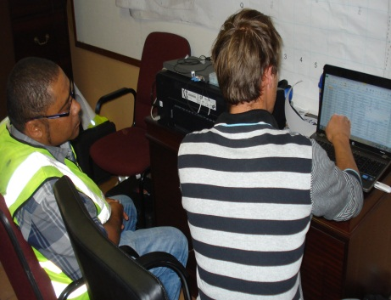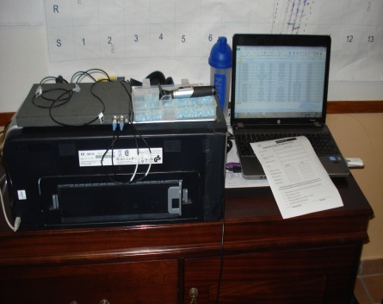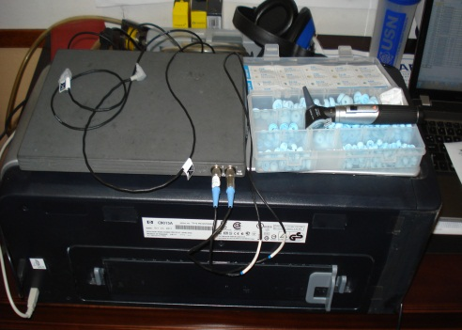

3.0 Items discussed
- According to the SD manager ± 2,200 employees are affected and is part of the program
- Hearing Coach is approximately (2) two years on site
- Being using Noise Clippers for ± the past (8) eight years
- Records are kept as evidence of the possible “Leading Practice” NIHL
- Names and evidence are kept of noise clippers issued to individuals
- Continuous Records are kept since 2010
- Noise clippers will have the most correct data as the service provider deals with that.

Question 1:
What do we do with all the info at this stage?
- We gather the info to build a history of each employee
Question 2:
Is the info gathered integrated with audiograms?
- No but it is available on request as we have our own data base (Service Provider)
Question 3:
Do you have any links (Software- Such as Everest) between hearing Coach and the mine data?
- No we don’t
Question 4:
What can we do to make it better and look good at our mine?
  - Identify all gaps in the current systems practiced
  - We need to use one integrated system
  - Do away with manual capturing to avoid trial and error
  - You have to have a proper change management system
  - Have a specific contract with the service provider and indicate your requirements and expectations from the supplier and service provider
  - Ensure proper evaluation of noise clipper and hearing coach (KPI/KPA) to ensure a return on investment on what results are achieved on the current capital lay-out.
  - OAE is loose standing and is separate from HPD management and noise clipper.
  - Your systems must “talk: to one another and must be available at the OH Centre as well as for the OHN/OMP. Current systems are used in isolation. This is to be verified
  - OAE’s – Does it combat or reduce NIHL? – Not sure, be sure you can proof due diligence with all your efforts and endeavors. This is to be verified
  - Employee records must be 100% correct (legal compliance) and all systems must be centralized and managed by a single person as evidence. Currently the service provider data is separate and is manually captured and not verified or checked by a third party or an independent person.
  - We believe the info provided from the service provider is correct as received
  - What happens with the leading indicators? It is captured and sent to the clinic
  - What happens with all the lagging indicators? It is also sent to the clinic
  - How are lagging indicators addressed and managed? It is part of the SD and management month report. Employees with PLH shifts are counseled. This is to be verified
  - Is there a link between Hearing Coach and the companies Hearing Conservation Program? There is an overlap between certain things. This is to be verified
  - Was a change management and paperwork updated for the function required from Hearing Coach? This is a gap and must be addressed
  - Is hearing coach, Baseline medicals, DMR Mandatory COP and medical surveillance programs integrated or linked? This is to be verified
  - A noise inventory of all equipment, activities, frequencies and OEL’s exists. This is to be verified
  - Medical surveillance data VS noise prevention, how is this measured and monitored in your HCP? This is to be verified
  - Occupational Hygienist- Counseling is done with affected employees if over the 2.5 PLH shift and is not familiar with the OHC scan as the mine only works on the audiogram results. This is to be verified
  - Hearing coach should pick up any movements prior to the audiogram otherwise what is the benefit of having the OAE? This is to be verified
  - Counseling sessions: Hearing coach does manual counseling on affected employees with hair cell damage. Trial and error
  - How do you determine which people must be counseled? The people with outer hair cell damage from 80%>
  - How are they classified? Green, Yellow and Red.
  - Which category receives counseling? The red category as they have shown damage
  - When will the yellow classification be counseled? One they are in the red category This is to be verified and amended as we concentrate on the wrong population as well
  - Where are these records kept? Records of PLH shifts are available on request from the service provider
  - How do you counsel people if they cannot read or write? It is difficult, I normally ask someone to translate if counseling is done in a group
  - Are you 100% sure and confident that the people know what they sign for once they are counseled? This is difficult to tell.
  - How are the filters set? They are all set with the attenuation levels.
  - Is it possible that some people cab over protected? Yes it is, but the company wants it that way.
  - Which noise clippers are set for which HEG’s? We don’t work on HEG’s, we work on area applicability, meaning noise clippers are area applicable.
  - OAE’s- We expect that the service provider will pick-up a hearing problem before any NIHL. We can, if we get all the people.
  - What training is conducted? We conduct post training on a 1:1 basis by completing a questionnaire which both of us signs.
  - Who set the training requirements and compliance? The service provider. This is to be verified
  - Is there anything specific? Yes we show the person his results and inform him/her of the hearing problem.
  - How do you determine if a person understands, do you have criteria to show C/NYC? (Competent/Not Yet Competent) No we don’t have it like that

- Service provider (Hearing Coach)
5.1 Does parades from all shafts
5.2 Who are paraded? The highest risk people
5.3 Do all of these high risk people have noise clippers? No, some have had noise clippers before we started off with Hearing Coach.
5.4 How does Hearing Coach work in relation to Noise clipper? We conduct seal test and takes normally about one week
5.5 Do all people have noise clippers when visiting you regarding OAE’s? No, some might not have noise clippers, but will use HPD’s
5.6 How long does it take to provide noise clippers to those after the mold was taken?
5.6.1 Anything between (4-6) four and six weeks.
5.7 What do these high risk people wear in the meantime? The HPD’s or disposables provided.
5.8 What do you inspect in the persons ear? To check if there is no infection or wax
5.9 What happens if infection or wax is present? The employee is referred to his own General Practitioner as this is not a job related thing.
5.10 Is the medical center informed of this referral? No, it is not a job related thing and the employee must report back to me once the problem is solved
5.11 Do you keep track of these employees? No we don’t
5.12 Does this mean he can get lost in the system if no tracking and tracing is done? Yes it is possible
5.13 Can this means his condition can worsen until the next parade is done? It is possible
5.14 Who are scheduled to be on the Hearing Coach Program? All high risk employees are on the Hearing Coach program. This is to be verified
5.15 People on the OAE program is not supposed to use any disposable HPD’s
5.16 What happens if they have to wait for their noise clippers when it is manufactured? Then they have to wear disposable ear plugs. This is to be verified
5.17 If you are alone, how is it possible to do all the work? We are two, people working together to do impressions.
5.18 How does parading of employees work? We plan and schedule them a week in advance. Parades are done via the clocking and SAP systems
5.19 Are these people paraded finished with their medical surveillance before visiting Hearing Coach? No, they first visit hearing Coach
5.20 During what times are these visits scheduled? Between 06H30-08H30
5.21 Do you have electronic records of all the company employees? No, we only have records of people that were previously paraded
5.22 What are the current filter settings of all people? All filters are set on 110DB’s across the board. This is to be verified
5.23 Does the medical center have the same records that you? No, we manage our own data base. This is to be verified
5.24 Are you working on any reports from the medical Centre? No, we work on our own records and reports on OAE’s
5.25 Do you have records of how many times a person was issued with Noise clippers? No. we only have a record when a once off was issued from us
5.26 What service do you provide? We do fitments, maintenance, impressions, group coaching etc.
5.27 How do you compare OAE’s against audiograms? We actually conduct a speech test which is different from the audiogram. We conduct a communication speech loss test which is also a functional test
5.28 How do you report on these findings? We send a month report to the medical center which include a damage index of the early detection of a noise problem this is to be verified
5.29 How do we find early detection with the OAE method? We concentrate on the high risk employees with damage from 86%-100% and gets reported to the OHN. Parades on counseling is then initiated from the OHN
5.30 Is there a link between Noise clipper, OAE and the company audiograms? No, each person runs with their own system (We need to link, link, link etc)
5.31 Do we all measure the same Hertz? 600 Hertz seems to be missed during audiograms. This is to be verified
5.32 How is the equipment in use calibrated? It is calibrated on a daily basis.
5.33 Do you have a calibration certificate for the program and graphs that get drawn up for an early detection? No I don’t, the unit in use get calibrated in Belgium every two years to the right frequencies.
5.34 How do you know it was not dropped and the frequencies changed? I believe it is correct
5.35 For what can the unit also being used? We use the unit for daily leakage and seal test before we start with the OAE measurements. When the figures shows in red on the graph, then we know the calibration and the ear seal test correspond
5.36 Does you medical history and those on the individual records at the medical center balance? We have to align it still
5.37 RMA’s and claims prevention programs to be verified regarding the efficiency of the OAE program
5.38 HCP info to audiologist, ENT and compensation/RMA to be linked and verified
5.39 RMA’s claims prevention programs to be verified as part of OAE success, reduction in PLH shifts and NIHL
5.40 Successes in the early Identification of hearing Loss. This is to be verified
5.41 We deal with two sections of HCP; Noise reduction and engineering revision;
- Medical surveillance is part of OAE
- Training from hearing coach
- Induction training
- Counseling
5.42 Hearing Coach; do they provide Xstrata with enough information to integrate the data into the overall OAE and Noise Management system? I.e. Rate of chance on audiograms and PLH?

6.0 Medical Records
- All types medical and training records to be linked and managed from a centralized database.
7.0 Challenge
- Separation of medical records from different individuals is to be combined???????????
- OAE’s records to improve-Only available data is from June 2012 although (2) two years on site
- Make sure what we need to measure, monitor, verify and correct as per action plans. We report on lagging indicators and do not address future NIHL cased as pointed out via OAE’s
- Follow ups from OAE’s are lagging which result in worst case scenarios due to employee management issues
- OAE’s and the 08 Audiograms frequencies to de analyzed and corrected as per noise prevention in the HCP programs
- Roving HEG’s are not considered in the selection of Noise Clippers. Area specific is chosen as the best option
- We know that Noise clippers are the best in the speech zone for the high risk employees.
- The speech specifications need to be determined and verified to ensure effectiveness and maximum protection as intended
- The service provider is of the opinion that a person can be over protected (Pre and Post measurement not clear)
- Filter calibration cannot be proven as it is set at the laboratory
- Qualification and certification of the equipment in use could not be provided
- To have an integrated electronic system as everybody works with “loose standing” data and is not readily available
8.0 Communication:
- Language barriers are problematic in discussing and sharing information especially to those illiterate groups.
- It was not clear whether buy-in from all stakeholders were obtained. This is to be verified
- Block parades are difficult to parade those who are not obeying the rules.
- Communication regarding referrals to own GP is not communicated via the medical center or line management, meaning the employee with the problem is not monitored until the next parade
- The employees with 2.5% shifts gets the attention of the OHN and not from line management as well
- RTS reports can be obtained from the service provider to be fed into the current Everest program

- Contractors:
- They are issued with Noise Clippers and will form part of the OAE program
- If no noise clippers are available for high risk employees, they wear disposable HPD’s
10.0 Quality control
- The system is not yet ”fool proof” due to the human elements involved such as not reporting back to hearing coach or is not attending the parade
- Control over the person in visiting his own GP for wax removal is to be optimized as we do not have a line function
- Slips do come through as the system does not yet cater for shortfall identified.
- Maintenance on site do have at times and employee build-up which can take time before an employee gets a new set of Noise clippers
- Q-Med will be the ideal to refine the reporting system

11.0 NIHL stats:
- The most accurate statistics is kept by the service provider
- Monthly reports are available as required by the DMR
- An electronic linking and capturing system is implemented to measure effectiveness, but historical data is not integrated into the complete HCP program
- The cost and success rate of the OAE system is still to be verified (Cash Flow Return On Investment-CFROI)

12.0 On-site service provider (Hearing Coach)
- Hearing Coach provides a full service including the following:
- Molds, Fitment, repairs, maintenance, recordkeeping, replacement, issuing, in ear inspection, training and administrative support.
- Shortfall – Not an integrated electronic management system. Manual inputs have the potential for flaws. This is to be refined and verified as per recommendation from an independent party??.
13. Main reason why a decision on Hearing Coach:
- To have a system in place for the early detection of possible NIHL way before it is shown at the annual audiograms.
- To have the capacity in identify leading indicators and to start with a colour coding system for counseling at an early stage
14. Hearing Coach and employee satisfaction surveys:
- Proof of these are not yet done, but apparently at shaft levels
- All molds are done at the on-site facility and fitments are done at shaft level. (leak tests not clear as well as certification and calibration for 100% compliance)
15. Training
- HPD Training and awareness Shortfall as HPD training materials is not yet fully implemented or build into induction programs as per selection tool. (Training center)
- Literacy is a problem as everybody does not understand or can read English or Afrikaans. Safety Representatives sign on behalf of these people
- Training records are yet to be verified
- Competency can yet not be demonstrated. The manual capturing still allow trial and error.
- No training curriculum is used as a prescriptive standard

16. General
16.1 The question remains if any R&D funding exists to continue with the refinement of the OAE process.
- JDB to submit the MHSC/SIMRAC request regarding R&D to Mr. A. Knoesen
- Dr Edwards will stay in touch to have the CSIR involved which will not be part of the Mosh and Learning Hub mandate
16.2 The best data is available for the last 3 years for verification amongst, Xstrata, Life (Clinic service provider) and Hearing Coach. (OAE service provider)
16.3 Historical mine data is not 100% up to date
16.4 OHC data base is being used
16.5 HPD data and noise clipper data is managed by the service provider. Xstrata does not manage these as it is part of the service provider’s contract
16.6 Noise HEG’s are not used as a decision was taken to issue all employees with noise clippers as per working area
16.7 Statistical data regarding date started, age, exposure and occupation is to be verified
16.7 CSIR is to consider Glencore Xstrata Mototolo Platinum as a “Pilot shaft” to make the OAE a LP.

Conclusion
- It is evident that a company must able to demonstrate that all systems work to the effect of success in the OAE LP in a sustainable and strategic way.
- The challenge is to have an integrated system to merge all the different systems in a single database as there are currently ± 5 data basis in use and the data is scattered
- It is clear that there is still refinement to be done before we can reach the point of certifying this OAE as a possible LP as NIHL still occurs.
- It is strongly recommended that the company must be able to indicate the value and contribution of the OAE early NIHL detection methodology in a simplistic way for industry to adopt.

Regards

José de Beer
Noise team manager
Mosh Learning Hub
Jdebeer01@xstrata.co.za
Cell: 082 6016725

