Report on the Noise Clipper Management verification investigation
Date of information gathering visit: 23rd May 2013
Venue: Impala Platinum Rustenburg
Introduction
Dr. Anita Edwards and Mr. Jose de Beer were tasked by the MOSH Noise team to investigate a possible leading practice after a proposal was received from Mr. Anton Botha (Ventilation Manager – Impala Platinum Rustenburg). A familiarization visit was conducted at Impala Platinum’s Occupational Hygiene offices and Occupational Health centre on 23rd May 2013 to start gather information and observe the process involved in the system as well as to interview the staff who are part of the system.
Proposed leading practice
The proposed leading practice is the Noise Clipper® (custom-made hearing protection devices) management system for the approximately 47,000 employees (including contractors) as outlines in Appendix A.
Impala HPD management system
- Uvex® and Noise Clippers® are the only two HPD’s used at Impala Platinum
- These were chosen on the reported improved speech intelligibility and on the reported attenuation from each type. The choice of these two HPDs was motivated by the amount of attenuation (30dB) provided by Noise Clippers® and an alternative for employees who were not able to wear Noise Clippers®. All employees and contractors are fitted with Noise Clippers®.
- Evidence of the attenuation provided by Noise Clippers® was not available.
- The HPDs procurement at Impala must comply with the New Equipment Policy which is managed by the internal new equipment committee. The New Equipment Policy requires both compliance with all other company policies and procedures and independent verification of the products.
- Since 2012 Contractors have been included in the Impala HPD program. The Shaft Sinkers contractors have been a particular challenge due to the very high levels of noise exposure and incidence of NIHL. In-depth investigations by independent consultants indicated that according to the documented specifications and in relation to measured noise exposure levels both Noise Clippers® and Uvex® can provide sufficient attenuation of noise for Shaft Sinkers if worn correctly and at all time. Therefore the need for dual protection has been ruled out.
- Rock drill operators (RDO’s) are the occupational group with the highest exposure levels and therefore the priority group for HPD fitting as well as effective monitoring procedures.
History of Impala HPD management system
2003 - only RDO’s had Noise Clippers® and there was a very slow roll out and duplications due to ineffective control and HPD’ s cost approximately R500 000.00.
2006 - SAP system was introduced and links made to HPD’s issued. Large discrepancies and costs identified.
2007 - stop issuing Noise Clippers®
2008 - establish an on-site facility as part of employment and record control
  - Category A&B employees collect pay slips and hand in their Noise Clippers® at the pay office in a secured safe for maintenance whilst they are on leave and collect again on return from leave as part of the medical surveillance route.

2012 - Noise Clippers® product was improved by inserting a seal test canal into all Noise Clippers®
Currently – Maintenance of Noise Clippers® includes deep cleansing, seal check and physical check. During the fitting and refitting, employee’s are shown how to insert the Noise Clippers® and electronic signatures on receipt are being introduced.
During maintenance the following takes place:
  - Filter replacement (whether broken or not) set at attenuation of 30dB
  - String replacement
  - Clips replacement
- Ultra sonic cleaning
All employees receive a new set of Noise clippers® every 5 years
Advantages of the system
- Individually fitted HPD can be personalised and managed for very large workforce
- Increased chance that the desired attenuation levels are achieved due to attention to individual differences in ear and canal shape
- Only .007% complaints are received from 47,000 employees about uncomfortable fitting
Reported Challenges
- Employees go on leave without handing in HPD’s and this causes delays during the medical surveillance process and loss of work time. The system of “no HPD, no leave payslip” has not been fully enforced. Weekly SHE meetings are used to discuss noise/HPD issues and employees are encouraged to hand in their HPD’s before going on leave.
- The HPD and HR records are being integrated but currently the lack of integration makes it difficult to track those who are not handing in their HPDs when going on leave as they are only identified when they return from leave. Records indicate that ± 26% of the workforce do not have their HPD’s tested annually.
- Only large contracting companies issued Noise Clippers® while smaller contracting companies provide disposable HPDs.
- NIHL persists - 36 NIHL cases were reported from Jan 2012-June 2012. 46% off the cases are RDO’s and the average age groups are 52 and the exposure of these people employees were on average 22 years.
Gaps identified
The following identified gaps in the Noise Clipper® management programme also apply for the Uvex alternative HPD issuing and management.

- HPD certification
There was no documented evidence available for the Noise Clipper® specifications of filter characteristics.

- HPD attenuation verification
There was no evidence of the maintenance steps documented or available for inspection. Evidence of seal test results also not available.

- HPD suitability
All employees are fitted with the same filter and exposure levels are not taken into account for the filter choice. This raises the possibility of overprotection and the risk of employees taking the HPD out to hear instructions or speech.

- HPD care and maintenance training
The training on the care and maintenance of the HPD and of the use and correct insertion in the ear was not documented, acknowledge in writing or evaluated.
- Compliance
As noted in the challenges above the employee compliance with handing in HPDs before going on leave has not been enforced and therefore the programme cannot be fully implemented.
The system on compliance of employees wearing their HPDs is not integrated into the Noise Clipper®.
No system is in place to monitor the effectiveness of the HPDs in the period between annual checks nor for employees with high risk such as exposure levels or problems with HPD fitting.

- Reduction in NIHL and value for money
Evidence of a reduction in NIHL as a result of the Noise Clipper programme implementation is not available and therefore the evidence of value for the high costs of the programme not justified.

- Inclusion of contractors in the programme
Smaller contractors are exempt from the HPD programme and no evidence of attempts to include them were available nor of the alternative arrangements made for the employees of the contractors

- Integration with the overall Hearing Conservation Programme (HCP)
The records of HPD issuing and maintenance as well as the training for use are not integrated with noise exposure and audiogram results in a way that facilitates monitoring and evaluation of the HCP or of the HPD management programme. Much of the capturing and recording is a manual process and results in the risk of errors.

- Documenting of the HPD management system for MOSH leading practice purposes
More detailed documenting of the process of implementing the proposed leading practice will be required for the MOSH adoption process with particular reference to the behaviour communication and the leadership communication processes used

Required refinements
- Integration of the databases of results for the audiogram recording system, the HPD issuing and maintenance and training provision and outcomes will facilitate the evaluation of the value and success of the HPD management system as well as facilitate the continual improvement of the system
- Analysis of the historical audiogram records to evaluate the reduction in NIHL as a result of the HPD programme
- Improved documenting of all aspects of the programme especially of the verification of attenuation and of seal fitting and of training and receipt of HPDs
- Enforcing the “no HPDs-no payslip” policy by including it in the HCP policy and by obtaining understanding and buy-in from the labour representatives. A reward system for compliance may be a possibility
- Monitoring of HPD effectiveness between annual testing of the high risk groups of employees
- Inclusion of all contractors in the programme
Conclusion
Once the noted refinements have been made the HPD management system holds a great deal of potential to be a leading practice for NIHL elimination

Appendix A: Report submitted by Impala Platinum

Retrofit Noise Control Practice on Offer from Industry
Name of Practice:

A facility for custom made hearing protection as well as the maintenance thereof.

Description of the Practice

Custom made hearing protection (noise clipper) is supplied to all permanent and long term contractors.
The facility for custom made hearing protection at Impala is situated at and form part of the route to obtain a certificate of fitness at the Occupational Health Centre (OHC). The facility or “room” for noise clippers is managed by noise clipper themselves.
As part of the impression / fitment process the maintenance of the noise clipper forms an integral part of hearing protection devices.
  - At Impala Platinum only two types of hearing protection are allowed:
  - UVEX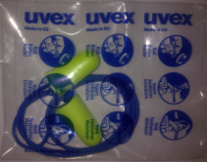
  - Noise Clipper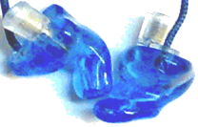

Hearing Protection Device will be issued to individuals as per std.03.02 - PPE

Benefits:
- Employees are issued with the best possible means of protection and maintenance is done on an annual basis.
- A planned monthly meeting with Noise Clipper is held to discuss operational issues related to the noise clipper project where information on the status of the project is shared.
- The SAP system is updated with employee information on fitment and maintenance. Information from the system is used to generate adhoc status reports such as in Annexure A to indicate who has not been issued. A monthly report is generated for inclusion into the month end report of each shaft.
Constraints:
- Employees do not hand it their noise clippers when collecting payslips at the time office. Supervisors do not communicate this regularly. (see minutes from HSE Steercom meeting)
- Employees do not adhere to parades for fitments.
- Employees fit noise clippers incorrectly.
- Employees “loose” their noise clipper to obtain new clippers, but std.03.00 – PPE make provision for replacement after an investigation.
Costs:
The issuing of noise clippers commenced somewhere in 2003 with a manual paper based system to manage the issuing. In 2004 and onwards Impala have spent about R500,000 per annum on duplications due to the manual system. In 2005 onwards an “Microsoft Access” program was used to prevent duplication and saved the R500,000 per annum. In 2007 the issuing of noise clippers was stopped and in 2008 a contract was signed where a facility was provided for issuing and maintenance of noise clippers. The table below indicates the cost implication for noise clippers alone.
Year | Sum of Amount | Rolling Total of Amount
Manual system
2004 | R 1,303,941 | R 1,303,941
2005 | R 2,157 | R 1,306,098
2006 | R 928,987 | R 2,235,085
2007 | R 49,638 | R 2,284,723
Contract with Noise Clipper Facility
2008 | R 3,762,878 | R 6,047,601
2009 | R 8,555,453 | R 14,603,054
2010 | R 7,919,680 | R 22,522,734
2011 | R 8,057,717 | R 30,580,451
2012 | R 3,654,978 | R 34,235,429

Test Results:

Although some individuals (about 0.03% of the total workforce) do complain the system in operation to cater for the 45’000 employees are functioning excellent.

Photograph:

Issuing of noise clippers as per std.

Maintenance of the noise clipper

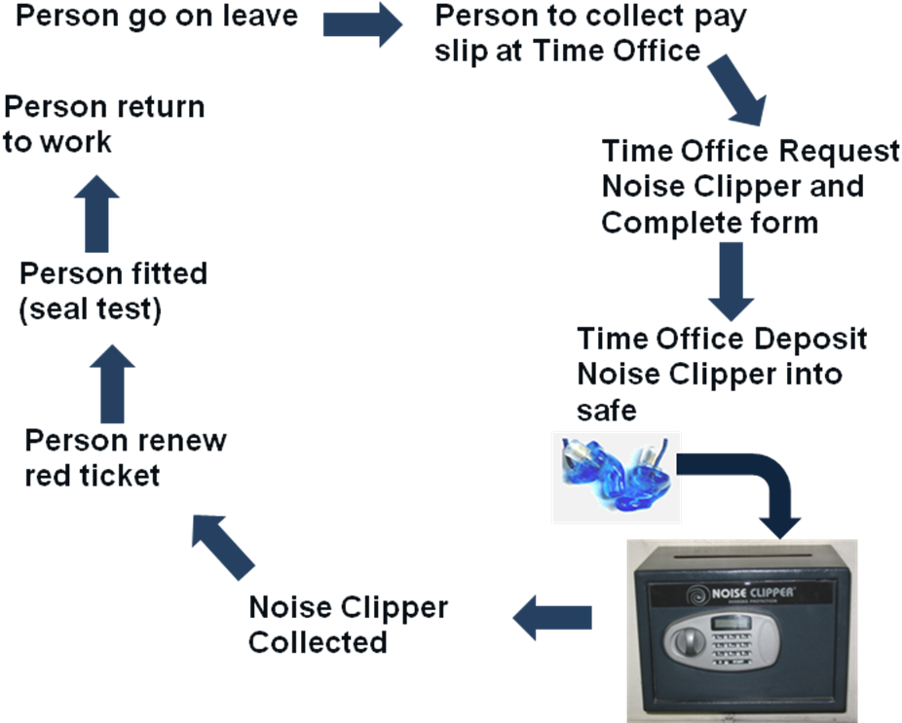

See std.06.24.02 Extract - Approved materials, vendors and noise tolerances

Contacts:
Name | Telephone Number | e-mail address
Anton Botha | 014 569 6538 | anton.botha@implats.co.za
Kathy Annandale | 014 569 7566 | kathy.annandale@implats.co.za
Casey Penyenye | 014 569 7566 | casey.penyenye@implats.co.za
Johan Nagel | 012 349 0700 | johann@noiseclipper.co.za

